Business Feedback & Rule Intelligence Engine (RIE)

System Documentation

System Overview
The Rule Intelligence Engine (RIE) is a standalone ML-assisted modular monolith that converts unstructured business feedback into structured business rule suggestions. The system classifies feedback, extracts one or more structured canonical rules, validates them against business schemas, identifies duplicate and conflicting rules, requests clarification for incomplete feedback, and routes suggestions for human review. Approved suggestions may be converted into draft business rules through a separate rule creation workflow, while rule activation is performed only through an explicit administrative action. At no point does the Rule Intelligence Engine automatically create, activate, modify, or deploy production business rules.

Execution-Level System Architecture

The Rule Intelligence Engine (RIE) is implemented as a modular monolith using a single FastAPI application that contains multiple independent internal modules responsible for processing unstructured business feedback into structured business rule suggestions. Each module has a well-defined responsibility and communicates through internal service interfaces rather than separate network calls. This architecture simplifies development, deployment, testing, and maintenance while allowing individual modules to evolve independently within a single deployable application.

The system processes business feedback through a structured pipeline consisting of feedback classification, rule extraction, schema validation, duplicate detection, conflict detection, clarification handling, review routing, and persistence. Long-running operations such as batch feedback analysis, model training, evaluation, and pgvector index management updates are executed asynchronously using Celery workers with Redis as the message broker, ensuring that API requests remain responsive while background tasks are processed reliably.

The system uses PostgreSQL as the primary transactional database, with pgvector for persistent vector storage and workspace-scoped semantic similarity search. Structured business rules are stored in normalized form and are compared using deterministic rule comparison after semantic candidate retrieval. Human reviewers approve or reject AI-generated suggestions, while business rule creation and rule activation remain separate administrative workflows to prevent unintended modification of production business rules.
The architecture consists of six logical layers:
1. Client Layer
2. API Layer
3. Rule Intelligence Engine (RIE)
4. Knowledge Sources
5. Persistence Layer
6. Human Review System
Each layer has clearly defined responsibilities to ensure separation of concerns, maintainability, security, traceability, and consistent enforcement of the business rule lifecycle.

Client Layer

The Client Layer represents any browser-based application, internal dashboard, or external system that submits business feedback to the Rule Intelligence Engine through REST APIs.

The client is responsible for:

• Submitting business feedback

• Sending authentication credentials

• Providing the requested workspace identifier

• Requesting suggestion and background job status

• Receiving structured JSON responses

The client never interacts directly with the database, machine learning models, or internal processing modules.

The client may specify a workspace identifier as part of the request; however, the Rule Intelligence Engine does not trust the supplied workspace identifier directly. The API Layer validates the authenticated user's workspace membership and authorizes access before processing the request, ensuring complete workspace isolation and preventing unauthorized cross-workspace access.

2.2 API Layer (FastAPI)
The FastAPI application serves as the single entry point for all client requests and coordinates communication between the internal modules of the Rule Intelligence Engine. It is responsible for request validation, authentication, authorization, workspace access validation, request routing, response generation, and coordination with asynchronous background jobs.
Its responsibilities include:
• Authentication and authorization
• Workspace membership validation
• Request validation
• Schema validation
• Request routing
• API response generation
• Coordination with background job processing
• Batch and individual request handling
• Audit logging and request tracing
The API Layer performs validation and orchestration but does not contain business logic. After successful authentication, the authenticated user's workspace membership is validated before any request is processed. Once validation is complete, the request is forwarded to the appropriate internal modules within the Rule Intelligence Engine. Long-running operations such as batch feedback analysis are submitted to Celery workers through Redis and executed asynchronously without blocking API requests.
Typical endpoints include:
• /v1/feedback/analyze
• /v1/feedback/batch-analyze
• /v1/jobs/{job_id}
• /v1/rules
• /v1/rules/{rule_id}/activate
• /v1/rules/check-duplicate
• /v1/rules/check-conflict
• /v1/taxonomy
• /health
2.3 Rule Intelligence Engine (RIE)

The Rule Intelligence Engine (RIE) contains the core business logic of the system. It consists of multiple independent internal modules, each responsible for a single stage of the analysis pipeline. These modules execute sequentially within the same FastAPI application as part of the modular monolith architecture and communicate through internal interfaces rather than network calls. Each module produces structured outputs that are consumed by downstream modules, enabling traceability, independent evaluation, and simplified maintenance.

2.3.1 Classification Module
The Classification Module analyzes incoming feedback to determine:
- Feedback type
- Rule category
- Business domain
- Actionability
- Whether clarification is required
The classification results are passed to downstream modules together with calibrated classification probabilities and supporting evidence. These outputs are evaluated independently and are not combined into a single overall confidence score.

2.3.2 Rule Extraction Module
This module converts unstructured business feedback into one or more structured canonical business rules by extracting:
• Business term
• Operation
• Structured conditions (field, operator, value)
• Scope
• Time window
• Threshold values
• Affected tables and columns
• Schema references
Extracted rule components are validated against the provided schema metadata before being included in the generated suggestion. Multiple independent rules may be extracted from a single feedback submission, with each extracted rule stored separately while maintaining traceability to the originating feedback and suggestion.

2.3.3 Duplicate & Conflict Detection Module
This module identifies duplicate and conflicting business rules using a two-stage comparison process. Candidate rules are first retrieved using semantic vector similarity through pgvector. Final duplicate and conflict decisions are then performed using structured rule comparison based on business term, operation, conditions, scope, time window, threshold values, and affected schema elements.
The module identifies:
• Exact duplicates
• Semantic duplicates
• Rule modifications
• Logical conflicts
• Contradictory conditions
The module never modifies existing business rules. Duplicate and conflict findings are recorded separately and routed for human review when required.

2.3.4 Clarification Module
If feedback lacks sufficient information or contains ambiguous business intent, the Clarification Module generates structured clarification requests.
The system never assumes or guesses missing business information. Clarification requests and user responses are stored separately from the original feedback. After clarification is received, a new analysis run is created using the original feedback together with the clarification response while preserving the original submission as an immutable record.

2.3.5 Confidence & Evidence Module
Each analysis stage produces its own calibrated probability, validation result, and supporting evidence. Classification, rule extraction, schema validation, duplicate detection, and conflict detection are evaluated independently rather than combined into a single overall confidence score.
Schema validation is represented using pass/fail status together with validation coverage. Low-confidence predictions, schema validation failures, missing mandatory fields, sensitive rules, or detected conflicts are automatically routed for manual review regardless of confidence values.

2.3.6 Review Routing Module
The Review Routing Module determines how a generated suggestion should be handled after automated analysis. Routing decisions are based on classification results, extraction results, schema validation, duplicate detection, conflict detection, clarification requirements, and configurable review policies.
This module only determines the review path. It does not approve, reject, create, activate, or modify business rules.

2.4 Knowledge Sources
The Rule Intelligence Engine uses multiple knowledge sources during analysis to improve classification accuracy, rule extraction, schema validation, and business rule comparison.
These include:
• Business glossary and taxonomy
• Schema metadata
• Active business rule repository
• Domain packs for supported business domains
• pgvector-based semantic rule index
These knowledge sources are read-only during automated analysis and are used to validate extracted rule components, resolve business terminology, perform semantic candidate retrieval, and compare structured rule representations against existing business rules. Semantic similarity is used only to retrieve candidate rules, while final duplicate and conflict detection is performed through structured rule comparison.

2.5 AI / ML Engine
The AI / ML Engine provides intelligent analysis capabilities used by the Rule Intelligence Engine. It consists of three primary components that support business feedback classification, structured rule extraction, semantic candidate retrieval, and model evaluation. The deterministic baseline remains the reference implementation, while machine learning models are evaluated independently before being considered for production deployment.
It consists of three primary components:

2.5.1 Deterministic Baseline
The deterministic baseline provides the reference implementation for system evaluation using:

• Regular expressions
• Keyword dictionaries
• Business taxonomies
• TF-IDF with Logistic Regression for classification
• Rule templates
• Structured rule normalization

The deterministic baseline serves as the benchmark against which all machine learning models are evaluated and also acts as the fallback mechanism if machine learning inference is unavailable.

2.5.2 Machine Learning Models
The initial machine learning implementation evaluates DistilBERT as a candidate model for:

• Feedback classification
• Named Entity Recognition (NER)
• Business rule extraction
• Semantic candidate retrieval

DistilBERT is treated as an initial machine learning candidate rather than the production model. Promotion to production requires measurable improvement over the deterministic baseline on a frozen evaluation dataset using predefined acceptance criteria.

The machine learning pipeline maintains separate models for classification and rule extraction. Model artifacts, tokenizer versions, configuration, evaluation metrics, and dataset versions are version-controlled to ensure reproducibility and traceability.

2.5.3 Evaluation Module
The Evaluation Module measures model performance using independently evaluated metrics, including:

• Precision
• Recall
• F1-score
• Confusion Matrix
• Confidence Calibration Error
• Complete Rule Accuracy
• Recall@K for semantic retrieval
• Duplicate Detection Precision and Recall
• Conflict Detection Precision and Recall

Evaluation results are compared directly against the deterministic baseline using the same frozen evaluation dataset before any model is promoted for production use. Detailed evaluation methodology is described in a later section of this document.

2.6 Persistence Layer (PostgreSQL)
PostgreSQL serves as the primary transactional database for the Rule Intelligence Engine, storing all persistent system data required for business feedback processing, human review, rule management, auditability, and machine learning traceability.

Persistent data includes:
• Submitted feedback
• Generated suggestions
• Extracted rules
• Business rules
• Review decisions
• Analysis runs
• Audit history
• Background jobs
• Dataset and model metadata
• Evaluation metrics
• Domain packs
Suggestions, extracted rules, and business rules are maintained as separate entities to ensure complete traceability throughout the business rule lifecycle. Every automated analysis creates an Analysis Run record that captures the model version, dataset version, taxonomy version, domain pack, processing mode, thresholds, and execution timestamps used during processing.
Approval of a suggestion changes only its review status. Business rule creation generates a draft business rule, while rule activation is performed separately through an explicit administrative action. This separation ensures that AI-generated suggestions never directly modify production business rules.

2.7 Human Review System

The Human Review System allows authorized reviewers to validate AI-generated suggestions before they are considered for business rule creation.
Reviewers may:
• Approve suggestions
• Reject suggestions
• Archive suggestions
• Request clarification

Human approval changes only the suggestion review status. It does not create, activate, modify, or deploy a business rule.

If clarification is requested, the original feedback remains unchanged. The clarification request and user response are stored separately, after which a new analysis run is created using the original feedback together with the clarification response.

proved suggestions become eligible for draft business rule creation through a separate workflow. Rule activation is performed independently through an explicit administrative action to ensure that production business rules remain under complete human control.

2.8 Response Layer
Once automated analysis is complete, the system returns a structured JSON response containing:
• Suggestion ID
• Processing status
• Classification results
• Extraction results
• Schema validation status
• Duplicate indicators
• Conflict indicators
• Clarification requirement (if applicable)
The API response confirms that the suggestion has been successfully analyzed and stored.
For asynchronous operations such as batch feedback analysis, the API returns a Job ID with an initial processing status. Clients can retrieve processing progress and generated suggestion IDs using the Job Status API.
Human review occurs independently after the response has been returned to the client, ensuring that API requests remain asynchronous with respect to manual review activities.
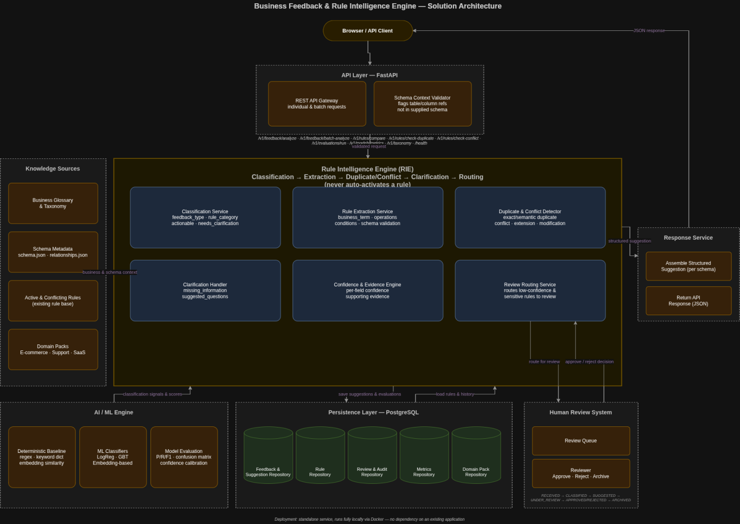

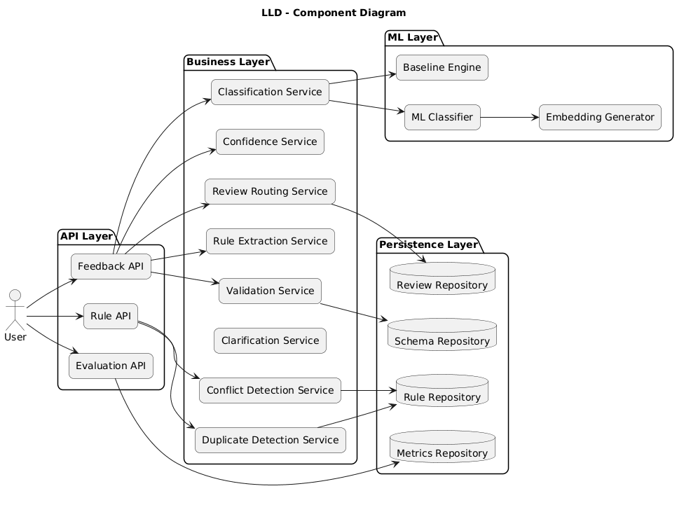

3. System Work-flow and Data Flow
The Rule Intelligence Engine (RIE) processes business feedback through three independent workflows:
• Feedback Analysis
• Human Review
• Rule Creation and Activation
Separating these workflows ensures that automated analysis, manual review, draft business rule creation, and business rule activation remain independent processes. This design prevents AI-generated suggestions from directly modifying production business rules and ensures that every business rule passes through explicit human review, draft rule creation, and administrative activation before becoming active.

3.1 Feedback Analysis Flow
The Feedback Analysis Flow begins when a client submits business feedback through the POST /v1/feedback/analyze endpoint. Each request includes the business feedback, authentication credentials, the requested workspace identifier, and optional schema context required for validation.
Upon receiving the request, the FastAPI application performs input validation, authentication, workspace membership validation, schema validation, request tracing, and audit logging. The supplied workspace identifier is authorized against the authenticated user's workspace memberships before processing begins. A unique Feedback ID is generated to maintain traceability throughout the processing lifecycle. After successful validation, the feedback is forwarded to the Rule Intelligence Engine for automated analysis.
The analysis pipeline consists of the following sequential stages:

Step 1 – Feedback Classification
The Classification Module analyzes the submitted feedback and predicts:
- Feedback type
- Rule category
- Business domain
- Actionability
- Clarification requirement
- Initial review priority
The classification result provides structured context for all subsequent processing stages.

Step 2 – Rule Extraction
The Rule Extraction Module converts the unstructured feedback into one or more structured canonical business rules by identifying and extracting:
- Business Term
- Operation
- Structured conditions (field, operator, value)
- Scope
- Time window
- Threshold values
- Affected tables and columns
- Schema references
Every extracted rule component is validated against the supplied schema metadata. Unknown tables, columns, business terms, or invalid operations are flagged rather than accepted automatically. A single feedback submission may generate multiple structured rules, each stored independently while maintaining traceability to the originating feedback.

Step 3 – Duplicate Detection
The Duplicate Detection Module compares the generated suggestion against previously approved business rules and existing suggestions to determine whether it represents:
- Exact Duplicate
- Semantic Duplicate
- Extension of an existing rule
- Modification of an existing rule
- Unrelated suggestion
Semantic similarity search using pgvector is first used to retrieve candidate rules. Final duplicate classification is then performed through structured rule comparison based on business term, operation, conditions, scope, time window, threshold values, and affected schema elements. The duplicate relationship is recorded for each extracted rule.

Step 4 – Conflict Detection
The Conflict Detection Module evaluates whether the proposed rule logically conflicts with existing active business rules.
Possible outcomes include:
- Direct Conflict
- Potential Conflict
- No Conflict
Conflict detection follows the same two-stage approach. Candidate rules are retrieved using semantic similarity, while final conflict determination is performed using structured rule comparison. Conflict results are recorded independently and later used during review routing.

Step 5 – Clarification Handling
If mandatory business information is missing or ambiguous, the Clarification Module identifies the missing information and generates structured clarification requests.
The system never assumes or invents missing business information. Clarification requests are stored separately from the original feedback. When a clarification response is received, a new Analysis Run is created using the original feedback together with the clarification response while preserving the original submission as an immutable record.

Step 6 – Confidence & Evidence Generation
Each stage of the analysis produces independent outputs, including calibrated classification probabilities, extraction probabilities, schema validation results, duplicate detection results, conflict detection results, and supporting evidence.
Schema validation is represented as pass/fail together with validation coverage rather than as a confidence score. These outputs are recorded separately to support explainability and human review.

Step 7 – Review Routing
Based on validation results, duplicate detection, conflict detection, clarification requirements, and classification results, extraction results, schema validation results, the Review Routing Module determines the appropriate review path.
Possible routing outcomes include:
• Normal Review
• High-Priority Review
• Clarification Required
• Validation Failure
• Mandatory Manual Review
Suggestions are automatically routed to mandatory manual review whenever schema validation fails, mandatory business fields are missing, sensitive business rules are detected, duplicate or conflict analysis identifies potential issues, or calibrated model outputs fall below configured thresholds.
The API immediately returns a response containing:
- Suggestion ID
- Current processing status
- Classification results
- Extraction results
- Schema validation status
- Duplicate status
- Conflict status
- Clarification requirement (if applicable)
The feedback analysis work-flow ends at this point. No business rule is created, modified, or activated during automated analysis.
3.2 Human Review Flow
The Human Review Flow operates independently after automated analysis has completed.
Authorized reviewers access the review dashboard and retrieve suggestions that are currently awaiting review.
For each suggestion, reviewers can examine:
- Original business feedback
- Structured rule suggestion
- Classification results
- Extracted business entities
- Duplicate detection results
- Conflict detection results
- Classification results
- Extraction results
- Schema validation results
- Supporting evidence
- Clarification requests (if applicable)
After evaluating the generated suggestion, reviewers may perform one of the following actions:
- Approve the suggestion
- Reject the suggestion
- Request Clarification
- Archive the suggestion
Each review action is recorded in the audit history together with:
- Reviewer identifier
- Decision
- Timestamp
- Review comments
Approval changes only the suggestion status to APPROVED. Approved suggestions become eligible for draft business rule creation through a separate workflow. Business rule activation requires an explicit administrative action and is performed independently of the review process.
If clarification is requested, the original feedback remains unchanged. The clarification request and response are stored separately, and the Rule Intelligence Engine creates a new Analysis Run using the original feedback together with the clarification response. This preserves a complete audit trail while ensuring that the original feedback remains immutable.

3.3 Rule Activation Flow
Business rule creation and activation are intentionally separated from the review workflow to ensure complete human control over production rule management.
Only suggestions with an APPROVED status are eligible for draft business rule creation.
The rule creation and activation workflow consists of the following stages:
• An approved suggestion is selected for draft rule creation.
• One or more structured extracted rules are converted into formal business rules.
• Each generated rule is validated against the active rule repository using structured rule comparison.
• The validated rule is stored in the Rule Repository with a status of DRAFT.
• An authorized administrator reviews the draft rule and explicitly invokes the Rule Activation API.
• The rule status is updated to ACTIVE and becomes available for downstream systems.
Only after successful activation does the rule become available for operational use.
This separation ensures that reviewer approval does not automatically create or activate production business rules. Business rule creation and rule activation remain independent administrative actions to prevent unintended deployment of AI-generated business logic.

3.4 Suggestion Lifecycle
Every submitted feedback progresses through a predefined lifecycle that ensures traceability and controlled rule management.
Status | Description
RECEIVED | Feedback successfully received by the API.
VALIDATED | Authentication, request validation, and schema validation completed.
CLASSIFIED | Feedback type, rule category, and actionability identified.
EXTRACTED | Structured rule information extracted from the feedback.
ANALYZED | Duplicate detection, conflict detection, schema validation, clarification analysis, and evidence generation completed.
PENDING_REVIEW | Suggestion stored and waiting for human review.
CLARIFICATION_REQUIRED | Additional business information is required. The clarification request is stored separately and a new Analysis Run is initiated after the clarification response is received.
APPROVED | Suggestion approved by an authorized reviewer.
REJECTED | Suggestion rejected after manual review.
READY_FOR_RULE_CREATION | Approved suggestion is eligible for draft business rule creation.
RULE_CREATED | Formal business rule generated, validated, and stored in the Rule Repository with a status of DRAFT.
RULE_ACTIVATED | An authorized administrator activates the draft business rule, making it available for operational use.
The lifecycle ensures that feedback, suggestions, extracted rules, draft business rules, and active business rules remain separate entities throughout the system. This separation preserves complete traceability, supports independent review and analysis, and prevents unintended modification of production business logic.
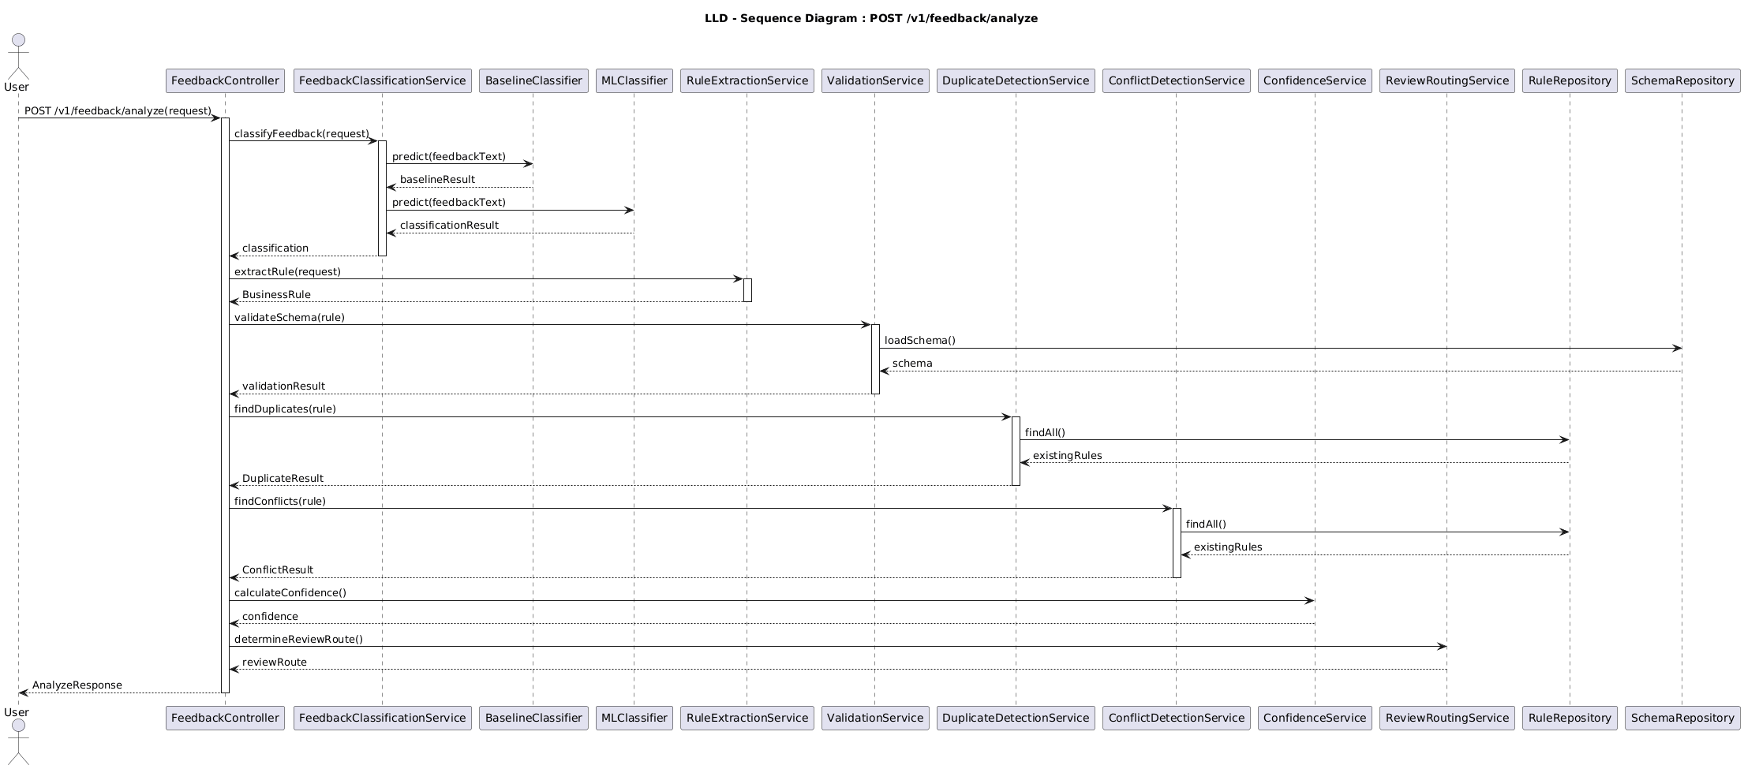

4. Data Sources and Dataset Preparation
The Rule Intelligence Engine (RIE) is designed as a standalone, domain-independent system and therefore does not rely on any existing production application, customer database, or client-specific business data. During development and evaluation, the system will be trained and tested using controlled datasets generated from synthetic business environments, publicly available datasets, and manually reviewed examples.
The primary objective of this approach is to create reproducible, domain-independent datasets for both feedback classification and structured rule extraction while ensuring that no sensitive production data is required during development. Separate datasets are maintained for classification, rule extraction, duplicate detection, conflict detection, and evaluation to enable independent training and assessment of each machine learning component.

4.1 Synthetic Feedback Dataset
The synthetic training data consists of independently annotated datasets for feedback classification and structured rule extraction. The initial dataset contains approximately 500–1,000 labelled business feedback examples covering all supported feedback categories, rule types, and business domains.
The datasets are generated using a combination of manually written examples, programmatic generation techniques, and Large Language Model (LLM)-assisted data generation. Every generated example is manually reviewed and annotated before being included in the training datasets to ensure label quality, annotation consistency, and reproducibility.
The synthetic dataset includes diverse feedback patterns such as:
- Metric definition changes
- Filter rules
- Status mappings
- Join corrections
- Time-based rules
- Entity definitions
- Calculation corrections
- Data-quality issues
- Access and scope rules
- Duplicate and near-duplicate feedback
- Contradictory rules
- Ambiguous feedback
- Non-rule product feedback
- Feedback containing grammatical errors
- Hinglish and conversational English examples
- Feedback containing multiple business rules in a single message
- Missing or incomplete business context
The datasets include examples containing single-rule and multiple-rule feedback, conversational English, Hinglish, incomplete business requirements, and ambiguous business intent. Each example is annotated separately for classification labels and structured rule extraction using predefined annotation guidelines to support independent evaluation of each machine learning task.
These variations improve the ability of both the deterministic baseline and machine learning models to generalize across different writing styles, business domains, conversational language, Hinglish, and multiple-rule business feedback.

4.2 Synthetic Business Domain Packs
To provide realistic schema context during classification, structured rule extraction, schema validation, duplicate detection, and conflict detection, the system includes synthetic business domain packs representing three independent business domains.
The initial domain packs include:

4.2.1 E-Commerce
Representative entities include:
- Customers
- Orders
- Order Items
- Products
- Payments
- Refunds
- Regions

4.2.2 Customer Support
Representative entities include:
- Customers
- Tickets
- Agents
- Departments
- Ticket Events
- Satisfaction Scores

4.2.3 SaaS Subscription Management
Representative entities include:
- Organizations
- Users
- Subscription Plans
- Invoices
- Payments
- Product Events
Each domain pack contains:
- Database schema
- Table relationships
- Business glossary
- Existing business rules
- Canonical rule definitions
- Domain-specific terminology
- Training, validation, and testing datasets
- Annotation guidelines
These domain packs provide realistic business context for classification, structured rule extraction, schema validation, semantic candidate retrieval, structured rule comparison, duplicate detection, and conflict analysis without exposing real customer information.

4.3 Public Datasets
Public datasets are incorporated to make the synthetic business environments more representative of real-world data distributions.
Suitable public sources include:
- Kaggle datasets
- UCI Machine Learning Repository
- Government open-data portals
- Public customer-support datasets
- Public e-commerce datasets
- Open-source sample databases such as Northwind and Chinook
Public datasets are used primarily to provide realistic schemas, attribute names, business terminology, and domain context. Since these datasets do not contain labelled business feedback or structured rule annotations, corresponding feedback examples are generated and manually annotated before being included in the project. Separate annotations are maintained for feedback classification and structured rule extraction to support independent model training and evaluation.
Public datasets are used only for development and evaluation purposes. All generated annotations undergo manual review before inclusion in the project datasets to ensure label consistency, reproducibility, and compatibility with the predefined annotation guidelines.

4.4 Manually Reviewed Evaluation Dataset
To ensure unbiased and reproducible evaluation, the project maintains a separate manually reviewed frozen evaluation dataset that is never used during model training, validation, or hyperparameter tuning. This dataset serves as the reference benchmark for comparing the deterministic baseline with candidate machine learning models.
This evaluation dataset contains:
- Business feedback
- Expected classification labels
- Expected structured business rules
- Duplicate relationships
- Conflict relationships
- Clarification requirements
- Expected reviewer decisions
- Ground-truth structured rule representations
The dataset serves as the ground truth for measuring classification performance, structured rule extraction accuracy, duplicate detection, conflict detection, clarification handling, and overall system behavior. All candidate machine learning models are evaluated against this frozen evaluation dataset and are promoted only if they demonstrate measurable improvement over the deterministic baseline according to the predefined acceptance criteria.

4.5 Data Preparation Strategy
The overall dataset is divided into independent subsets for model development, validation, and evaluation. Separate datasets are maintained for feedback classification, structured rule extraction, duplicate detection, conflict detection, and clarification handling to enable independent training and assessment of each machine learning component.
Dataset | Approximate Size | Purpose
Training | ~600 examples | Model training
Validation | ~150 examples | Hyperparameter tuning and threshold selection
Frozen Evaluation (Testing) | ~200 examples | Final performance evaluation and baseline vs candidate model comparison
Duplicate Pairs | ~150 pairs | Duplicate detection evaluation
Conflict Pairs | ~150 pairs | Conflict detection evaluation
Ambiguous Examples | ~100 examples | Clarification handling evaluation
To prevent data leakage, paraphrases of the same underlying business rule are always kept within the same dataset split. The frozen evaluation dataset remains unchanged throughout model development and is used exclusively for final benchmarking and comparison between the deterministic baseline and candidate machine learning models.

4.6 Data Privacy and Independence
The Rule Intelligence Engine is intentionally designed to operate without any dependency on production environments or customer-specific business data.
During development:
- No production customer data is used.
- No existing product database is required.
- No client-specific business rules are referenced.
- All datasets are anonymized, synthetic, or publicly available.
- Production feedback, if incorporated in future versions, must first undergo manual review and anonymization before being considered for training purposes.
This approach ensures that the system remains portable, reproducible, privacy-compliant, and suitable for deployment across multiple business domains. Any future incorporation of production feedback must follow defined data governance policies, including anonymization, manual review, dataset versioning, and approval before inclusion in any training or evaluation dataset.
4.7 Dataset Annotation Guidelines
To ensure consistency across training and evaluation datasets, every feedback sample follows a standardized annotation process. Separate annotations are maintained for feedback classification and structured rule extraction to support independent model training and evaluation.
Each feedback instance is annotated with the following attributes:
• Feedback Type
• Rule Category
• Actionability
• Clarification Requirement
• Business Term
• Operation
• Conditions (Field, Operator, Value)
• Scope
• Time Window
• Threshold Values
• Affected Tables and Columns
• Duplicate Relationship
• Conflict Relationship
• Number of Extracted Rules
• Named Entity Recognition (NER) Labels
Named Entity Recognition annotations identify business entities such as Business Terms, Operations, Tables, Columns, Conditions, Threshold Values, Scope, and Time Windows. Feedback containing multiple independent business rules is annotated with separate structured rule representations for each extracted rule. Hinglish and conversational English examples follow the same annotation guidelines to ensure consistent labeling across different writing styles.
All annotations are independently reviewed by at least two reviewers. In cases of disagreement, the sample is escalated for senior review before being included in the gold-standard evaluation dataset.
These annotation guidelines ensure consistent labels across all datasets, improve annotation quality, and support reproducible evaluation of both the deterministic baseline and candidate machine learning models.
4.8 Dataset Distribution and Rule Families
To reduce class imbalance and improve model generalization, the synthetic dataset maintains balanced representation across all supported business rule categories while preserving relationships between logically equivalent business rules.
The approximate dataset distribution is shown below.
Category Approximate Distribution

Metric Definition 30%
Filter Rules 20%
Mapping Rules 15%
Access Rules 15%
Data Quality Rules 10%
Ambiguous / Clarification Cases 10%
Logically equivalent business rules are grouped using a unique rule_family_id. The rule_family_id identifies paraphrases or equivalent representations of the same underlying business rule. It is not used to group different rules extracted from the same feedback submission. Feedback and extracted rules remain linked through feedback_id and suggestion_id.
For example:
Rule Family ID: RF001
• Revenue should exclude cancelled orders.
• Cancelled orders must not contribute to revenue.
• Revenue calculation should ignore cancelled orders.
Although these feedback statements differ linguistically, they represent the same underlying business rule and therefore share a common rule_family_id.
This grouping enables robust duplicate detection evaluation while preventing logically equivalent rules from being distributed across different dataset splits. Different business rules extracted from the same feedback receive separate extracted rule records while sharing the same feedback_id, but they are assigned different rule_family_id values unless they represent equivalent business logic.
4.9 Dataset Versioning and Source Tracking
Every dataset used by the Rule Intelligence Engine is version controlled to ensure reproducibility, traceability, and consistency across model training, evaluation, and deployment. Each model evaluation and analysis run references the corresponding dataset version used during execution.
Each dataset version records:
• Dataset Version
• Creation Date
• Source
• License Information
• Annotation Version
• Number of Samples
• Business Domain
• Supported Machine Learning Task

The primary dataset sources include:
• Synthetic Feedback (Internal)
• Public Datasets (Original License)
• Business Glossary (Internal)
• Manual Annotations (Internal)
Maintaining dataset version history enables reproducible experiments, simplifies comparison between different model versions, and ensures that every evaluation run and analysis run can be traced back to the exact dataset version used during execution.

5. REST API Specification
The Rule Intelligence Engine exposes RESTful APIs through the FastAPI application to support feedback analysis, rule comparison, review management, taxonomy retrieval, and health monitoring. All APIs communicate using JSON and return standardized HTTP status codes along with structured response payloads.
Every request is associated with an authenticated user. Workspace access is determined by validating the authenticated user's workspace membership before request processing, ensuring complete tenant isolation, authorization, and auditability.

5.1 Authentication
All protected endpoints require authentication before processing requests.
Each request includes:
Authorization: Bearer <JWT Token>
Content-Type: application/json
Authentication is validated before any business processing begins. Unauthorized requests return an HTTP 401 Unauthorized response.

5.2 POST /v1/feedback/analyze
This endpoint accepts a single business feedback request and initiates the automated analysis workflow.

Request
{
"workspace_id": "WS001",
"feedback_text": "Revenue should exclude cancelled orders and test transactions.",
"context": {
"available_tables": [
"orders",
"payments"
],
"available_columns": [
"orders.status",
"orders.is_test",
"payments.amount"
]
}
}

The supplied workspace identifier is validated against the authenticated user's authorized workspace memberships before request processing begins.

Response
{
"suggestion_id":"SG1001",
"status":"PENDING_REVIEW",
"classification_result":"RULE_CHANGE",
"extraction_result":"COMPLETED",
"schema_validation":"PASS",
"duplicate_status":"NONE",
"conflict_status":"NONE",
"clarification_required":false
}
The endpoint completes after storing the generated suggestion. Human review occurs independently and is not part of the API request lifecycle.

5.3 POST /v1/feedback/batch-analyze
Processes multiple feedback requests asynchronously within a single API call.

The endpoint immediately returns HTTP 202 Accepted together with a Job ID. Batch analysis is executed asynchronously by Celery workers. Clients retrieve processing progress, failures, and generated Suggestion IDs using the Job Status API.

Request
{
"workspace_id": "WS001",
"feedback": [
{
"feedback_text": "Revenue should exclude cancelled orders."
},
{
"feedback_text": "Managers should only access their assigned region."
}
]
}

Response
{
"job_id":"JOB1021",
"status":"QUEUED"
}

5.4 POST /v1/rules/check-duplicate
Compares a proposed business rule with existing suggestions and active business rules to determine duplicate relationships.

Response includes:
- Duplicate Status
- Relationship Type
- Similar Rule IDs
- Similarity Candidates

5.5 POST /v1/rules/check-conflict
Determines whether a proposed business rule conflicts with existing active rules.

Response includes:
- Conflict Status
- Conflict Type
- Conflicting Rule IDs
- Recommended Review Action

5.6 GET /v1/suggestions/{suggestion_id}
Returns the latest processing status of a previously generated suggestion.

Response
{
"suggestion_id": "SG1001",
"status": "UNDER_REVIEW",
"classification_result":"RULE_CHANGE",
"extraction_result":"COMPLETED",
"schema_validation":"PASS",
"duplicate_status": "none",
"conflict_status": "potential_conflict",
"review_required": true
}

5.7 POST /v1/review
Allows authorized reviewers to submit review decisions for generated suggestions.

Request
{
"suggestion_id": "SG1001",
"decision": "APPROVE",
"comments": "Business rule is valid."
}
Possible review decisions include:
- APPROVE
- REJECT
- REQUEST_CLARIFICATION
- ARCHIVE
Approval updates only the suggestion status. Approved suggestions become eligible for draft business rule creation through a separate Rule Creation API.

5.8 POST /v1/rules
Creates a draft business rule from an approved suggestion.
Only approved suggestions are eligible for rule creation.
Request
{
"suggestion_id":"SG1001"}
Response
{
"rule_id":"RULE204",
"status":"DRAFT"
}

5.9 POST /v1/rules/{rule_id}/activate
Activates an existing draft business rule.
Only users with administrator permissions may invoke this endpoint.
Request
{}
Response
{
"rule_id":"RULE204",
"status":"ACTIVE"
}

5.10 Background Job Processing
Certain operations performed by the Rule Intelligence Engine are computationally intensive and may require several minutes to complete. To prevent API requests from blocking until these operations finish, such tasks are executed asynchronously through Celery workers using Redis as the message broker.
When a background job is created, the API immediately returns a unique Job ID and an initial processing status. Clients can monitor progress using the Job Status API.
The following operations execute as background jobs:
- Batch Feedback Processing
- Dataset Generation
- Model Training
- Evaluation Runs
- Pgvector index management Updates
- Bulk Rule Re-indexing

5.11 POST /v1/jobs/train-model
Starts training a new machine learning model using the selected dataset version.

Request
{
"dataset_version": "DS_v2.1",
"model_type": "DistilBERT"
}

Response
{
"job_id": "JOB1001",
"status": "QUEUED",
"message": "Model training has been scheduled."
}
The endpoint returns immediately after the training job is registered. Model training is performed asynchronously by the background worker.

5.12 POST /v1/jobs/generate-dataset
Creates a new dataset version by combining synthetic feedback, manually reviewed examples, and public datasets.

Request
{
"domain": "Finance",
"sample_size": 1000
}

Response
{
"job_id": "JOB1020",
"status": "QUEUED"
}

5.13 POST /v1/jobs/run-evaluation
Starts a complete evaluation of the current ML pipeline against the manually reviewed test dataset.

Response
{
"job_id": "JOB1050",
"status": "QUEUED"
}
The evaluation executes in the background and stores the results as a new Evaluation Run.

5.14 POST /v1/jobs/update-embedding-index
Updates the pgvector semantic search index after newly approved rules have been added to the repository.

Request
{
"workspace_id":"WS001"
}

Response
{
"job_id":"JOB1088",
"status":"QUEUED"
}
Pgvector index management updates are performed asynchronously to avoid delaying user requests.

5.15 GET /v1/jobs/{job_id}
Returns the current status of a background job.

Response
{
"job_id":"JOB1001",
"job_type":"MODEL_TRAINING",
"status":"RUNNING",
"progress":65,
"started_at":"2026-07-30T14:10:00Z",
"completed_at":null
}
Possible job states include:
- QUEUED
- RUNNING
- COMPLETED
- FAILED
- CANCELLED

5.16 POST /v1/clarifications/{suggestion_id}
Allows reviewers or business users to submit additional information requested during clarification.

Request
{
"clarification_response":"Exclude only cancelled orders created after payment confirmation."
}

Response
{
"suggestion_id":"SG1001",
"status":"REPROCESSING"
}
The clarification response is stored separately while the original feedback remains unchanged. A new Analysis Run is created using the original feedback together with the clarification response before the suggestion returns to the review workflow.

5.17 GET /v1/taxonomy
Returns the supported feedback categories, rule categories, duplicate relationships, conflict relationships, and review-routing options used by the Rule Intelligence Engine.
This endpoint allows client applications to remain synchronized with the latest system taxonomy.

5.18 GET /health
Returns the operational status of the Rule Intelligence Engine.
Example response:
{
"status": "healthy",
"database": "connected",
"model": "loaded",
"version": "1.0.0"
}
This endpoint is primarily intended for deployment monitoring and health checks.

5.19 Standard HTTP Response Codes
HTTP Status | Description
200 OK | Request processed successfully
201 Created | Resource created successfully
400 Bad Request | Invalid request payload or schema
401 Unauthorized | Authentication failed
403 Forbidden | User lacks required permissions
404 Not Found | Requested resource does not exist
409 Conflict | Duplicate request or conflicting resource
422 Unprocessable Entity | Request validation failed
500 Internal Server Error | Unexpected server error

5.20 API Design Principles
- All APIs are stateless and communicate using JSON.
- Workspace access is validated using the authenticated user's workspace membership.
- Automated analysis of APIs return immediately after storing generated suggestions or registering asynchronous jobs.
- Suggestion approval, draft rule creation, and rule activation are exposed through separate APIs.
- Every API request and background job is logged for auditing and traceability.

6. Database Design
The Rule Intelligence Engine uses PostgreSQL as its primary persistence layer for storing business feedback, generated rule suggestions, review decisions, active business rules, audit history, and evaluation data.
The database schema is designed to maintain a clear separation between submitted feedback, generated suggestions, extracted rules, draft business rules, active business rules, and analysis runs. This separation ensures complete traceability throughout the business rule lifecycle and prevents AI-generated suggestions from directly modifying production business rules without explicit human approval and administrative activation.

6.1 Database Overview
The database consists of the following primary entities:
Entity | Purpose
Feedback | Stores original feedback.
Suggestion | Stores generated suggestions.
Analysis Run | Records metadata for each execution of the Rule Intelligence Engine.
Extracted Rule | Stores structured rules extracted from suggestions.
Business Rule | Stores approved business rules.
Review | Stores review decisions.
Rule Comparison | Stores duplicate and conflict analysis.
Clarification Response | Stores clarification requests and responses.
Background Job | Tracks asynchronous operations.
Dataset Version | Tracks training and evaluation datasets.
Model Version | Tracks trained ML models.
Evaluation Run | Stores model evaluation results.
Audit History | Stores audit logs.
Workspace | Maintains tenant isolation.
Domain Pack | Stores domain metadata.

6.2 Feedback Entity

The Feedback table stores every feedback request exactly as submitted by the client.

Key Attributes
Attribute | Description
feedback_id | Unique identifier for the feedback.
workspace_id | Workspace to which the feedback belongs.
feedback_text | Original business feedback.
submitted_by | User who submitted the feedback.
created_at | Submission timestamp.
processing_status | Current processing state of the feedback.
Each feedback record remains immutable after submission to preserve traceability.
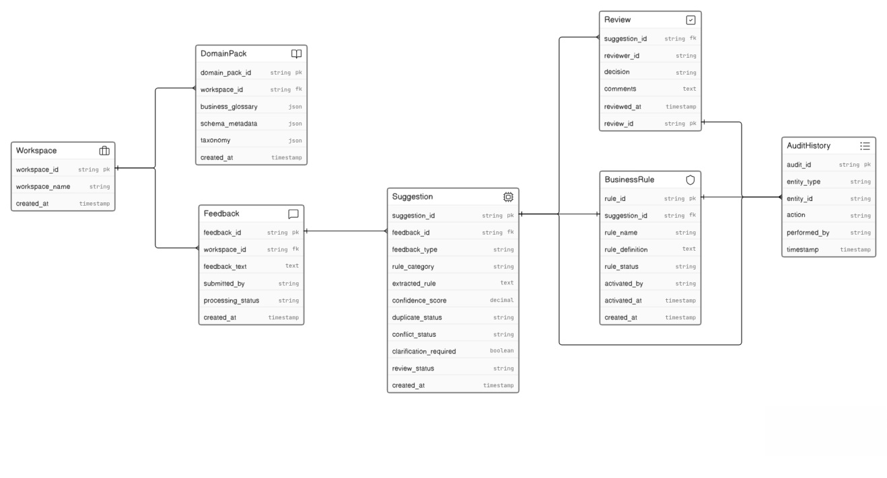

6.3 Suggestion Entity
The Suggestion table stores the structured rule suggestions generated by the Rule Intelligence Engine.

Key Attributes
Attribute | Description
suggestion_id | Unique suggestion identifier.
feedback_id | Reference to the original immutable feedback.
analysis_run_id | Reference to the Analysis Run that generated the suggestion.
feedback_type | Predicted feedback type and classification result.
rule_category | Predicted business rule category.
classification_result | Classification output maintained separately from other analysis results.
extraction_result | Extraction outcome, such as Completed, Partial, or Failed.
schema_validation_status | Schema validation result: PASS, PARTIAL, or FAIL.
duplicate_status | Duplicate relationship classification.
conflict_status | Conflict analysis result.
clarification_required | Indicates whether additional business information is required.
review_status | Current human review status.
created_at | Suggestion creation timestamp.
The structured rules extracted from a suggestion are stored as separate Extracted Rule records. A single suggestion may therefore contain multiple extracted rules without storing the rule structure directly inside the Suggestion entity.
Classification, extraction, schema validation, duplicate detection, and conflict detection results are maintained as separate analysis outputs. No single combined confidence score is stored as the decision-making authority for the suggestion.

6.4 Business Rule Entity
Business rules are stored separately from generated suggestions.
Only approved suggestions may be converted into draft business rules. Business rules remain in the DRAFT state until explicitly activated by an authorized administrator.

Key Attributes
Attribute | Description
rule_id | Unique business rule identifier.
suggestion_id | Source suggestion from which the rule was created.
rule_name | Human-readable rule name.
rule_definition | Structured rule logic.
rule_status | Draft, Active, Disabled, or Archived.
activated_by | Administrator who activated the rule.
activated_at | Rule activation timestamp.
Separating business rules from suggestions ensures that reviewer approval alone does not affect production business logic.
6.5 Review Entity
The Review table records every human review decision performed on generated suggestions.

Key Attributes
Attribute | Description
review_id | Unique review identifier.
suggestion_id | Reviewed suggestion.
reviewer_id | Reviewer performing the evaluation.
decision | Approve, Reject, Clarification Requested, Archive.
comments | Optional reviewer remarks.
reviewed_at | Review timestamp.
Each suggestion may undergo multiple review iterations if clarification is requested.

6.6 Audit History Entity
The Audit History table records all important system and user actions to ensure traceability and accountability.
Typical audit events include:
- Feedback submission
- Suggestion generation
- Review decisions
- Rule creation
- Rule activation
- Status changes
- API access events

Key Attributes
Attribute | Description
audit_id | Unique audit record.
entity_type | Feedback, Suggestion, Rule, Review.
entity_id | Associated entity identifier.
action | Action performed.
performed_by | User or system component.
timestamp | Action timestamp.
Audit records are immutable and retained for compliance and debugging purposes.

6.7 Workspace Entity
The Workspace entity enables logical separation of data across different organizations or projects.
Each workspace maintains independent:
- Feedback
- Suggestions
- Business rules
- Review history
- Domain packs
Workspace isolation ensures that users can access only the information belonging to their authorized workspace.

6.8 Domain Pack Entity
Domain Packs provide the business context required by the Rule Intelligence Engine.
Each domain pack contains:
- Schema metadata
- Business glossary
- Existing business rules
- Table relationships
- Supported terminology
- Domain configuration
- Canonical rule definitions
These domain packs are referenced during classification, entity extraction, duplicate detection, and conflict analysis.

6.9 Extracted Rule Entity
The Extracted Rule entity stores the structured business rules generated by the Rule Extraction module before duplicate detection, conflict detection, and human review. Since a single feedback submission may contain multiple business rules, each extracted rule is stored independently while maintaining a reference to the originating feedback and suggestion.

Key Attributes
Attribute | Description
extracted_rule_id | Unique extracted rule identifier.
suggestion_id | Parent suggestion.
rule_family_id | Groups paraphrases or equivalent representations of the same underlying business rule.
business_term | Primary business concept.
operation | Rule operation (Include, Exclude, Restrict, etc.).
conditions | Normalized conditions represented as field, operator, and value.
scope | Business scope.
time_window | Applicable time period.
affected_tables_columns | Database fields affected by the rule.
extraction_confidence | Calibrated confidence associated with the extracted rule components, derived using the defined confidence-calibration approach rather than treating raw model probability as calibrated confidence.
schema_validation_status | Validation result of the extracted rule against the available schema metadata.
The primary relationships between entities are illustrated below.
Workspace
│
├──────────────┐
│ │
▼ ▼
Feedback Domain Pack
│
├────────────────────────────────────────────┐
│ │
▼ ▼
Analysis Run Audit History
│
├──────────────┬───────────────┐
│ │ │
▼ ▼ ▼
Suggestion Model Version Dataset Version
│ │ │
│ └──────┬────────┘
│ ▼
│ Evaluation Run
│
├──────────────┐
│ │
▼ ▼
Extracted Rule Review
│ │
│ ▼
│ Business Rule (DRAFT)
│ │
│ ▼
│ Business Rule (ACTIVE)
│
▼
Rule Comparison
Feedback
│
▼
Clarification Response
│
▼
Analysis Run (Re-analysis)
Background Job
│
├── Batch Processing
├── Model Training
├── Dataset Generation
├── Evaluation Run
└── pgvector Index Update
This relationship model ensures complete traceability from the original feedback submission to the final activated business rule.

6.10 Analysis Run Entity
The Analysis Run entity records the configuration and execution metadata associated with each processing attempt performed by the Rule Intelligence Engine. It provides reproducibility and traceability by recording which model, dataset, taxonomy, domain configuration, thresholds, and processing mode were used to generate a suggestion.

Key Attributes
Attribute | Description
analysis_run_id | Unique identifier for the analysis execution.
feedback_id | Reference to the immutable feedback being processed.
model_version_id | Model version used during the analysis.
dataset_version_id | Dataset version associated with the model or evaluation configuration.
taxonomy_version | Taxonomy version used for classification and rule categorization.
domain_pack_id | Domain Pack used for schema and business-context validation.
threshold_configuration | Duplicate, conflict, classification, and routing thresholds used during the run.
processing_mode | Processing mode, such as baseline, ML, or batch processing.
started_at | Timestamp when analysis execution started.
completed_at | Timestamp when analysis execution completed.
status | Current execution state such as RUNNING, COMPLETED, FAILED, or CANCELLED.
Each analysis execution receives a unique analysis_run_id. Re-analysis after clarification creates a new Analysis Run while preserving the original feedback and previous analysis results.
This allows the system to reproduce and audit how a particular suggestion was generated without overwriting previous analysis results.

6.11 Rule Comparison Entity
The Rule Comparison entity stores the results of duplicate detection and conflict detection performed against existing business rules.
Each comparison record provides an explainable audit trail describing why a suggestion was classified as a duplicate, modification, conflict, or unique rule.

Key Attributes
Attribute | Description
comparison_id | Unique comparison identifier.
extracted_rule_id | Rule being compared.
compared_rule_id | Existing rule used for comparison.
relationship_type | Duplicate, Semantic Duplicate, Modification, Conflict, Unique.
candidate_similarity_score | Candidate retrieval similarity score.
comparison_summary | Structured comparison result.
duplicate_result | Duplicate detection confidence.
conflict_result | Conflict detection confidence.

6.12 Clarification Response Entity
The Clarification Response entity stores additional business information submitted after the system requests clarification for incomplete or ambiguous feedback.

Key Attributes
Attribute | Description
clarification_id | Unique clarification identifier.
suggestion_id | Associated suggestion.
clarification_question | Generated clarification request.
clarification_response | User response.
responded_by | User providing clarification.
responded_at | Timestamp.
processing_status | Pending, Reprocessing, Completed.
Clarification requests and responses are stored independently while the original feedback remains immutable. Every clarification response initiates a new Analysis Run, preserving complete traceability throughout the review process.

6.13 Background Job Entity
The Background Job entity tracks long-running asynchronous operations executed asynchronously by Celery workers using Redis as the message broker
Examples include:
- Model Training
- Dataset Generation
- Evaluation Runs
- Batch Feedback Processing
- Pgvector index management Updates

Key Attributes
Attribute | Description
job_id | Unique job identifier.
job_type | Type of background operation.
status | Queued, Running, Completed, Failed.
progress | Completion percentage.
created_at | Job creation time.
started_at | Execution start time.
completed_at | Completion time.
initiated_by | User who started the job.

6.14 Dataset Version Entity
The Dataset Version entity maintains version control for datasets used during model training and evaluation.

Key Attributes
Attribute | Description
dataset_version_id | Dataset version identifier.
version_name | Human-readable version.
dataset_size | Number of labelled samples.
business_domains | Included business domains.
source | Synthetic, Public, Manual Review.
annotation_version | Annotation guideline version.
created_at | Creation timestamp.
supported_ml_task | Machine learning task supported by the dataset.

6.15 Model Version Entity
The Model Version entity stores metadata for every trained machine learning model deployed within the Rule Intelligence Engine.

Key Attributes
Attribute | Description
model_version_id | Model identifier.
model_name | DistilBERT, SBERT, etc.
training_dataset | Dataset version used.
evaluation_run | Associated evaluation.
model_status | CANDIDATE, APPROVED, ACTIVE, ARCHIVED.
created_at | Training completion timestamp.
model_artifact_location | Storage location of the trained model artifacts.
tokenizer_version | Version of the tokenizer used during model training and inference.
cpu_memory_requirement | Minimum CPU and memory resources required to run the model.

6.16 Evaluation Run Entity
The Evaluation Run entity stores the results of benchmark evaluations performed on trained models.

Key Attributes
Attribute | Description
classification_f1 | F1-score achieved for the feedback classification task.
complete_rule_accuracy | Accuracy of extracting complete structured business rules.
recall_at_k | Recall@K score for semantic candidate retrieval.
duplicate_precision | Precision of duplicate rule detection.
duplicate_recall | Recall of duplicate rule detection.
conflict_precision | Precision of conflict detection.
conflict_recall | Recall of conflict detection.
calibration_error | Error between predicted probabilities and observed outcomes.
evaluated_at | Timestamp when the evaluation was completed.
evaluation_run_id – Unique evaluation execution identifier. | evaluation_run_id – Unique evaluation execution identifier.
model_version_id – Model evaluated during the run. | model_version_id – Model evaluated during the run.
dataset_version_id – Frozen dataset used for evaluation. | dataset_version_id – Frozen dataset used for evaluation.

6.17 Analysis Run Entity
The Analysis Run entity records every execution of the Rule Intelligence Engine for a feedback submission. A new Analysis Run is created whenever feedback is initially analyzed or reprocessed following a clarification response.
Key Attributes
- analysis_run_id – Unique analysis execution identifier.
- feedback_id – Associated feedback.
- model_version – Machine learning model used.
- dataset_version – Dataset version used.
- taxonomy_version – Taxonomy version used.
- domain_pack – Domain pack use
- processing_mode – Single or Batch processing.
- threshold_configuration – Active threshold configuration.
- started_at – Analysis start timestamp.
- completed_at – Analysis completion timestamp.
6.17 Design Considerations
The database design follows the following principles:
- Feedback, suggestions, extracted rules, draft business rules, and active business rules are stored as separate entities.
- Every analysis execution is recorded as an Analysis Run.
- Review decisions never directly create or activate production business rules.
- Workspace membership validation enforces tenant isolation.
- Audit history records every significant system and administrative event.
- pgvector is used for persistent semantic candidate retrieval.
- The schema supports future extension without requiring major structural changes.
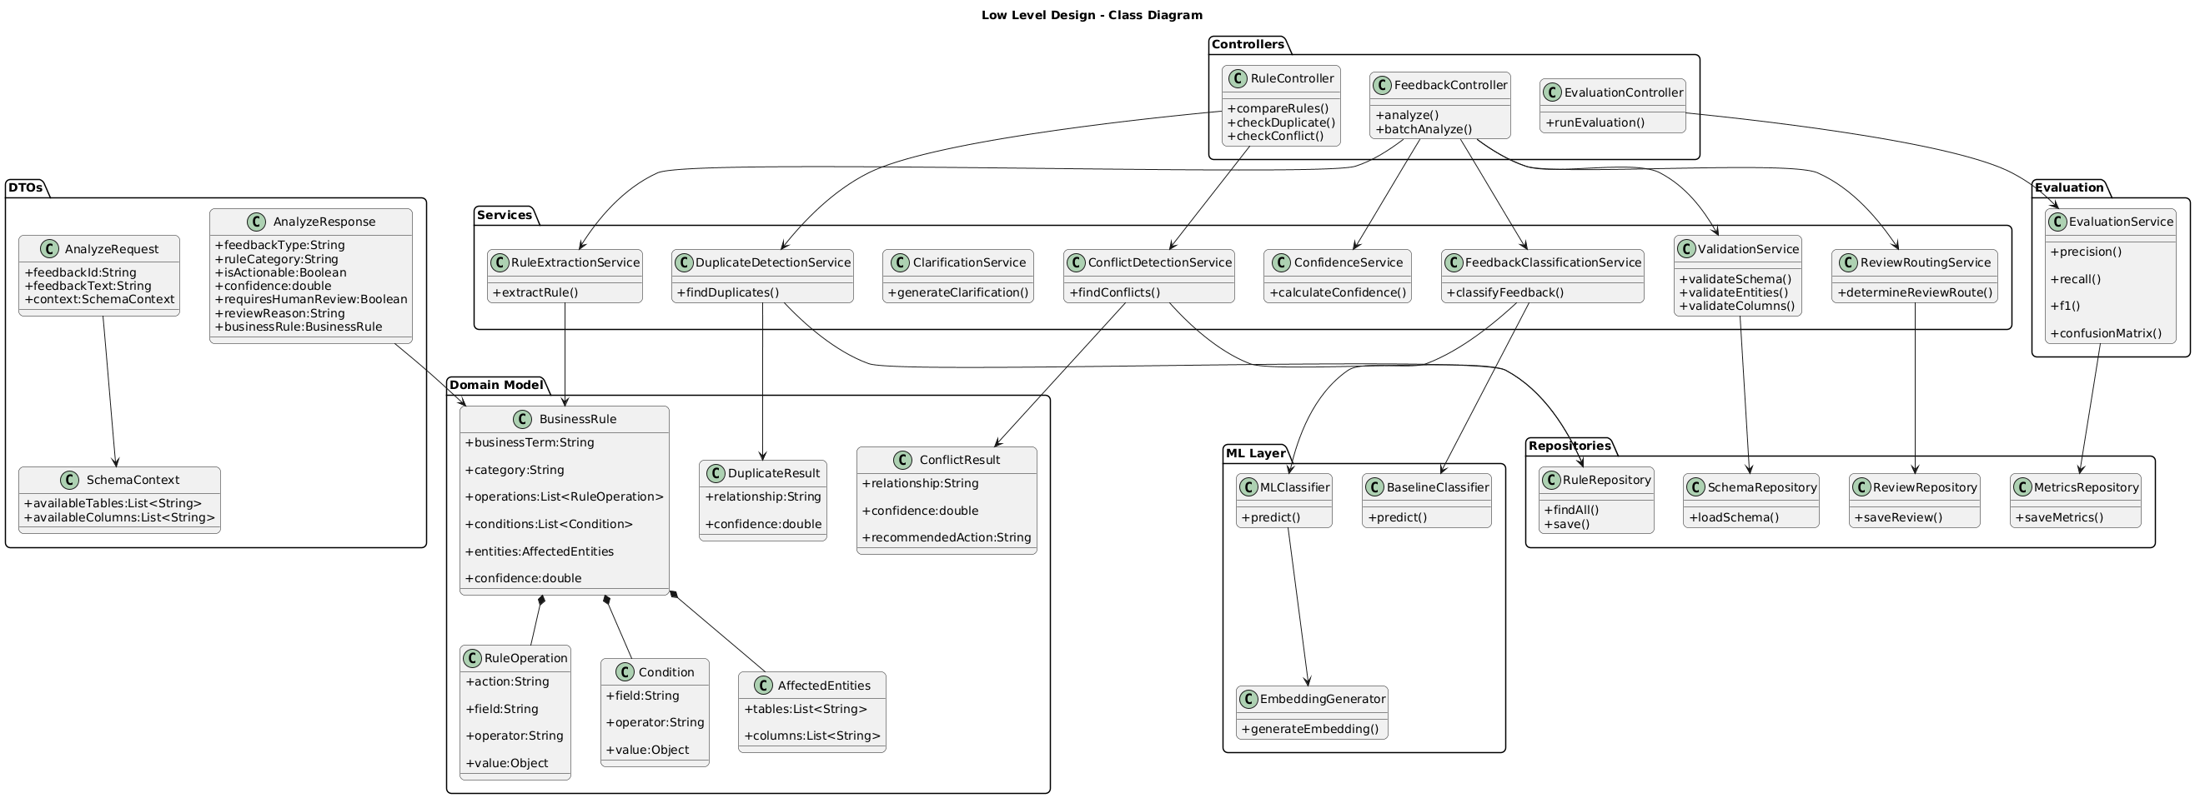
7. Suggestion Lifecycle
The Rule Intelligence Engine (RIE) maintains three independent lifecycle models to separate feedback processing, suggestion management, and active business rule management. This separation ensures that AI-generated suggestions never directly modify production business rules and that every stage remains independently auditable.
The three lifecycles are:
- Feedback Lifecycle
- Suggestion Lifecycle
- Business Rule Lifecycle
Although these lifecycles are related, they operate independently and communicate only through well-defined transitions. Suggestion approval does not create a business rule, business rule creation produces a draft rule, and only an explicit administrative activation makes a rule active.

7.1 Feedback Lifecycle

Feedback Submitted
│
▼
RECEIVED
│
▼
VALIDATED
│
▼
ANALYSIS RUN CREATED
│
▼
PROCESSING
│
▼
PROCESSED
│
▼
ARCHIVED

Feedback States
State | Description
RECEIVED | Feedback accepted by the API.
VALIDATED | Authentication, workspace and request schema verified.
PROCESSING | Classification and rule extraction pipeline executing.
PROCESSED | One or more suggestions generated successfully.
ARCHIVED | Feedback retained for audit and traceability.
ANALYSIS RUN CREATED | Analysis Run initialized for automated processing.
The Feedback lifecycle ends once the generated suggestions are successfully stored. All subsequent operations occur within the Suggestion lifecycle.

7.2 Suggestion Lifecycle
Suggestion Generated
│
▼
PENDING REVIEW
├──────────────┬──────────────┬──────────────┐
▼ ▼ ▼ ▼
APPROVED REJECTED CLARIFICATION REQUIRED ARCHIVED
│
▼
READY FOR RULE CREATION
│
▼
RULE CREATED (DRAFT)

Suggestion States
State | Description
GENERATED | Structured suggestion stored after processing.
PENDING REVIEW | Waiting for reviewer evaluation.
APPROVED | Business logic accepted by reviewer.
REJECTED | Suggestion rejected.
CLARIFICATION REQUESTED | Awaiting additional information.
READY FOR RULE CREATION | Eligible for conversion into a business rule.
RULE CREATED (DRAFT) | Draft business rule created from the approved suggestion.

Important: Suggestion approval confirms only that the proposed business logic is acceptable. The generated business rule remains inactive until explicitly activated through the Business Rule lifecycle.
Important: If clarification is requested, the original feedback remains unchanged. The clarification response is stored separately and a new Analysis Run is created before the updated suggestion re-enters the review lifecycle.

7.3 Business Rule Lifecycle

RULE CREATED (DRAFT)
│
▼
DRAFT
│
▼
ACTIVE
│
├──────────────┐
▼ ▼
MODIFIED RETIRED

Rule States
State | Description
RULE CREATED | Rule generated from an approved suggestion.
DRAFT | Available for administrative verification.
ACTIVE | Business rule currently enforced.
MODIFIED | Updated after business changes.
RETIRED | Rule removed from production while retained for audit history.
Only authorized administrators may activate, modify or retire business rules.

7.4 Lifecycle State Transitions
Not every state can transition directly to another state. The Rule Intelligence Engine enforces controlled state transitions to preserve consistency and auditability.
Current State | Allowed Next State(s)
RECEIVED | VALIDATED
VALIDATED | ANALYSIS RUN CREATED
ANALYSIS RUN CREATED | PROCESSING
PROCESSING | PROCESSED
DUPLICATE & CONFLICT ANALYSIS | CLARIFICATION CHECK
CLARIFICATION CHECK | SUGGESTION GENERATED, CLARIFICATION REQUESTED
SUGGESTION GENERATED | PENDING REVIEW
PENDING REVIEW | APPROVED, REJECTED, CLARIFICATION REQUESTED
APPROVED | READY FOR RULE CREATION
READY FOR RULE CREATION | RULE CREATED
RULE CREATED (DRAFT) | ACTIVE
Any invalid state transition is rejected by the system and recorded in the audit history.

7.5 Human Review Workflow
Human review is intentionally separated from automated analysis.
During review, an authorized reviewer evaluates:
- The extracted business rule.
- Classification accuracy.
- Duplicate and conflict analysis.
- Classification results, extraction results, schema validation results, and supporting evidence.
- Any clarification requests generated by the system.
- If clarification is requested, the clarification response is stored separately and a new Analysis Run is initiated while preserving the original feedback as an immutable record.

The reviewer may perform one of the following actions:
- Approve the suggestion.
- Reject the suggestion.
- Request Clarification if additional information is required.
- Archive the suggestion if it is no longer relevant.
All review actions are recorded in the Audit History repository.

7.6 Rule Creation and Activation
Approval of a suggestion does not automatically create or activate a business rule.
The rule management workflow is intentionally separated into two stages:
- Suggestion Approval – Confirms that the generated suggestion is valid from a business perspective.
- Draft Rule Creation – Creates a draft business rule from an approved suggestion.
- Rule Activation – Activates the draft business rule through an explicit administrative action.
This separation prevents accidental deployment of AI-generated business logic and ensures that production rules remain under explicit human control.

7.7 Exceptional Lifecycle Scenarios
The lifecycle also defines how exceptional cases are handled:
Scenario | System Action
Low-confidence or low-calibration prediction | Route suggestion to mandatory manual review together with classification results, extraction results, schema validation status, and supporting evidence.
Duplicate feedback detected | Link the suggestion to the existing record instead of creating redundant rules.
Conflicting business rule detected | Flag the conflict and require reviewer approval before proceeding.
Missing or ambiguous information | Store a clarification request separately, preserve the original feedback, and create a new Analysis Run after the clarification response is received.
Schema validation failure | Route suggestion to mandatory manual review before rule creation.
Invalid request | Reject during validation and return an appropriate API error response.
Model inference failure | Fall back to the deterministic baseline and record the event in the audit history.

8. Rule Processing and Decision Logic
The Rule Intelligence Engine (RIE) converts unstructured business feedback into structured business rule suggestions through a deterministic, modular processing pipeline implemented within a single FastAPI application. Each module performs one independent responsibility and produces structured outputs that are consumed by subsequent stages. The pipeline is intentionally sequential to improve traceability, simplify debugging, and support independent evaluation of each processing component.
Every stage records intermediate outputs, calibration results, validation results, and supporting evidence, enabling complete auditability and allowing reviewers to understand how a particular suggestion was generated. An Analysis Run record captures the model version, dataset version, taxonomy version, domain pack, processing mode, threshold configuration, and execution timestamps for every pipeline execution.
Feedback
│
▼
Input Validation
│
▼
Preprocessing
│
▼
Classification
│
▼
Rule Extraction
│
▼
Schema Validation
│
▼
Semantic Candidate Retrieval (pgvector)
│
▼
Structured Duplicate Detection
│
▼
Structured Conflict Detection
│
▼
Completeness Check
│
▼
Review Routing
│
▼
Suggestion Storage

8.1 Input Validation
Before any machine learning model is executed, the API validates the incoming request.
The validation stage verifies:
- Authentication token.
- Workspace membership authorization.
- JSON schema.
- Required request fields.
- Maximum feedback length.
- Supported content type.
- Duplicate request identifier (Idempotency Key).
Requests failing validation immediately return an appropriate HTTP error response without entering the processing pipeline.
Authorization verifies that the authenticated user is permitted to access the requested workspace before analysis begins.
8.2 Feedback Preprocessing
The preprocessing module normalizes the submitted feedback while preserving its business meaning.
Operations performed include:
- Unicode normalization.
- Whitespace normalization.
- Sentence segmentation.
- Tokenization.
- Removal of unnecessary punctuation.
- Business keyword preservation.
- Detection of schema references.
- Basic spelling correction (optional).
- Language normalization for conversational English and Hinglish.
Example:
Input : Revenue shouldnt include cancelld orders...
Output : Revenue should not include cancelled orders.
No business information is added or inferred during preprocessing.

8.3 Feedback Classification
The objective of the classification module is to determine whether the submitted feedback contains actionable business logic and to categorize it before downstream processing begins.
The classification module generates calibrated predictions for four independent classification tasks:
Prediction | Description
Feedback Type | Identifies whether the feedback represents a business rule, issue report, feature request, question, or general feedback.
Rule Category | Categorizes actionable feedback (Metric Rule, Filter Rule, Mapping Rule, Access Rule, Join Rule, etc.).
Actionable | Determines whether rule extraction should continue.
Clarification Requirement | Predicts whether additional information is likely to be required before rule extraction.

Raw model probabilities are calibrated before downstream decision making. Classification outputs are recorded independently and are not combined into a single overall confidence score.

8.3.1 Baseline Approach
The baseline classifier provides the deterministic reference implementation used for benchmarking candidate machine learning models.
- Regular Expressions
- Business Keyword Dictionaries
- TF-IDF Vectorization
- Logistic Regression Classifier
Pipeline:
Feedback
│
▼
Text Cleaning
│
▼
TF-IDF Vectorization
│
▼
Logistic Regression
│
▼
Predicted Category
The TF-IDF vectorizer converts feedback into sparse numerical vectors representing word importance. A Logistic Regression classifier is then trained on labelled feedback examples to predict the feedback category.

Advantages
- Fast inference
- Explainable predictions
- Easy debugging
- Provides a reproducible performance baseline
- This deterministic approach serves as the evaluation baseline for model comparison and as the fallback mechanism if no candidate machine learning model satisfies the predefined promotion criteria.

8.3.2 Machine Learning Implementation
The initial candidate machine learning classifier uses the Hugging Face checkpoint distilbert-base-uncased, fine-tuned for multi-class feedback classification. The model is considered a candidate until it demonstrates measurable improvement over the deterministic baseline on the frozen evaluation dataset.
The initial candidate model is selected for evaluation because it:
- understands semantic meaning
- handles conversational language
- works well with short business feedback
- approximately 40% smaller than BERT
- faster inference
The candidate model predicts the following independent outputs:
- Feedback Type
- Rule Category
- Actionable
- Clarification Required
simultaneously.

Training and Annotation Dataset
Training data consists of:
- Manually annotated classification dataset
- Synthetic business feedback
- Reviewer-approved business feedback
- Public datasets (where applicable)
Data is split into
70% Training

15% Validation

15% Frozen Evaluation

The frozen evaluation dataset is never used during model training, validation, or hyperparameter tuning.
No feedback from the testing dataset is used during training.

Model Input
{
"workspace":"Finance",
"feedback":"Revenue should exclude cancelled orders."
}
Before inference:
Lowercase

↓

Tokenization

↓

Attention Mask

↓

Tokenizer Encoding

↓

DistilBERT

Model Output
{
"feedback_type":"Business Rule",
"rule_category":"Metric Definition",
"actionable":true,
"clarification_required":false,
"classification_probability":0.96
}
Classification probabilities are calibrated before downstream decision making and are recorded independently from extraction, validation, duplicate detection, and conflict detection results.

Implementation Details
- Python Libraries
- transformers

- torch

- scikit-learn

- datasets
- Training Pipeline
Dataset

↓

Tokenizer

↓

DistilBERT

↓

Fine Tuning

↓

Validation

↓

Model Registry
- Inference
FastAPI

↓

Load DistilBERT

↓

Predict

↓

JSON
- Evaluation
Classification performance is measured using
- Accuracy
- Precision
- Recall
- Macro F1
- Weighted F1
- Per-category F1
- Confusion Matrix
The deterministic baseline and the candidate DistilBERT model are evaluated on the same frozen evaluation dataset. The candidate model is promoted only if it demonstrates measurable improvement over the deterministic baseline according to the predefined acceptance criteria.

Model | Role
TF-IDF + Logistic Regression | Deterministic baseline
DistilBERT (distilbert-base-uncased) | Initial candidate model
BERT | Alternative candidate
RoBERTa | Alternative candidate

Configuration | Value
Model Checkpoint | distilbert-base-uncased
Tokenizer | DistilBertTokenizerFast
Maximum Sequence Length | 256 tokens
Batch Size | 16
Optimizer | AdamW
Learning Rate | 2e-5
Execution Hardware | CPU-based inference with optional GPU support during training

Classification Task | Labels
Feedback Type | • Business Rule• Issue Report• Feature Request• Question• General Feedback
Rule Category | • Metric Definition• Filter Rule• Mapping Rule• Access Rule• Join Rule• Data Quality Rule

8.4 Rule Extraction
The Rule Extraction module converts actionable business feedback into one or more structured business rules. The module identifies business entities and rule components from natural-language feedback and then transforms these components into the canonical Rule JSON structure defined for the Rule Intelligence Engine.
The extraction process is divided into two stages:
- Entity/Span Extraction – identifies relevant business terms, operations, fields, values, scopes and temporal expressions from the feedback.
- Rule Construction – converts the extracted entities into one or more structured rules containing explicit field, operator, and value conditions.
The original feedback remains immutable. All extracted rules are associated with the corresponding feedback_id and analysis_run_id.
A single feedback request may produce multiple independent rules.

8.4.1 Extraction Task Definition
The extraction task is treated as a structured information-extraction problem rather than simple text classification.

Input
The extraction module receives:
- Original feedback text
- Workspace/domain identifier
- Domain glossary
- Schema metadata
- Available tables and columns
- Previous clarification response, if applicable

Output
The module produces one or more structured rules containing:
- business_term
- operation
- conditions
- scope
- time_window
- affected_tables
- affected_columns
- rule_family_id
- Extraction evidence
- Per-field extraction confidence
The output is then passed to schema validation before duplicate and conflict analysis.

8.4.2 Annotation Scheme
The training dataset uses the BIO annotation format for token-level entity extraction.
The BIO scheme represents:
- B-<LABEL> – beginning of an entity
- I-<LABEL> – continuation of an entity
- O – token outside any annotated entity
The initial extraction labels are:
Label | Description | Example
BUSINESS_TERM | Business metric or concept | Revenue
OPERATION | Business operation | exclude
FIELD | Database field referenced by a rule | orders.status
VALUE | Value used by a condition | Cancelled
SCOPE | Scope of application | Finance region
TIME_WINDOW | Temporal constraint | current quarter
THRESHOLD | Numeric comparison value | 50000
TABLE | Referenced database table | orders
COLUMN | Referenced database column | status
Conditions are not stored as a single text span in the final rule representation.
Instead, extracted FIELD, OPERATION, and VALUE information is transformed into a structured condition:
{
"field": "orders.status",
"operator": "EQUALS",
"value": "Cancelled"
}
The BIO annotation format is therefore used for identifying relevant spans, while the Rule Builder is responsible for converting those spans into the canonical structured representation.

8.4.3 Deterministic Baseline
A deterministic extraction baseline is implemented before evaluating the ML approach.
The baseline uses:
- Regular expressions
- Business dictionaries
- Domain glossary
- Schema metadata
- Predefined operation mappings
- Rule templates
- Linguistic patterns
Example operation mappings include:
Input Phrase | Normalized Operation
exclude | EXCLUDE
do not include | EXCLUDE
include | INCLUDE
only | RESTRICT
greater than | GREATER_THAN
less than | LESS_THAN
equal to | EQUALS
The deterministic baseline provides an interpretable reference implementation against which candidate ML models are evaluated.

8.4.4 Machine Learning Approach
The initial ML approach uses a Transformer-based token-classification model for entity extraction.
distilbert-base-uncased is treated as the initial candidate model, not as the final production model.
The candidate will be compared against:
- Deterministic extraction baseline
- TF-IDF/statistical baseline where applicable
- Transformer-based NER candidate
- Multilingual Transformer candidate if Hinglish performance indicates that an English-only model is insufficient
The final model will be selected only if it demonstrates measurable improvement on the frozen evaluation dataset while satisfying the defined safety and extraction-quality thresholds.
The model-selection process is therefore:
Deterministic Baseline
│
├──────────────┐
▼ ▼
TF-IDF/Statistical Transformer Candidate
│ │
└──────┬───────┘
▼
Frozen Evaluation
│
▼
Model Promotion Gate
│
┌───────┴────────┐
▼ ▼
Candidate Pass Candidate Fails
│ │
▼ ▼
APPROVED MODEL Retain Baseline

8.4.5 Model Input
The model receives tokenized feedback text.
Domain information is supplied separately to the extraction and Rule Builder layers rather than being treated as arbitrary text.
Example:
{
"feedback_text": "Revenue should exclude cancelled orders.",
"workspace_id": "WS001",
"domain": "ecommerce",
"schema_context": {
"tables": ["orders"],
"columns": ["orders.status"]
}
}
The schema context is subsequently used to validate and normalize extracted entities.

8.4.6 Model Output
The token-classification model produces token-level labels.
Example conceptual output:
Revenue → B-BUSINESS_TERM
should → O
exclude → B-OPERATION
cancelled → B-VALUE
orders → B-TABLE
. → O
The Rule Builder then combines these extracted spans with schema metadata to construct the canonical rule.
Example:
{
"business_term": "Revenue",
"operation": "EXCLUDE",
"conditions": [
{
"field": "orders.status",
"operator": "EQUALS",
"value": "Cancelled"
}
],
"scope": "GLOBAL",
"time_window": null,
"affected_tables": ["orders"],
"affected_columns": ["orders.status"],
"rule_family_id": "RF-001"
}
The model itself therefore performs entity extraction, while the Rule Builder performs structured rule construction.

8.4.7 Multiple Rule Extraction
A single feedback message may contain multiple independent business requirements.
Example:
Revenue should exclude cancelled orders, and only Finance Managers may modify revenue reports.
The extraction pipeline identifies two independent rule structures:

Rule 1
{
"business_term": "Revenue",
"operation": "EXCLUDE",
"conditions": [
{
"field": "orders.status",
"operator": "EQUALS",
"value": "Cancelled"
}
]
}

Rule 2
{
"business_term": "Revenue Reports",
"operation": "RESTRICT",
"conditions": [
{
"field": "user.role",
"operator": "EQUALS",
"value": "Finance Manager"
}
]
}
Both rules retain the same feedback_id and analysis_run_id, but represent separate business rules.
A rule_family_id is assigned independently and is used only to group paraphrases or equivalent versions of the same underlying rule. Different rules must not share the same rule_family_id.

8.4.8 Hinglish and Language Handling
The initial dataset contains conversational English and Hinglish examples because business feedback may not always follow formal English grammar.
Examples include:
Revenue mein cancelled orders include nahi hone chahiye.
and:
Managers ko sirf apne region ka data access karna chahiye.
Hinglish examples are annotated using the same BIO scheme and mapped to the same canonical rule representation.
Extraction performance is evaluated separately on:
- Standard English
- Conversational English
- Hinglish
If the initial English Transformer candidate demonstrates unacceptable performance on Hinglish data, a multilingual Transformer candidate will be evaluated before model promotion.

8.4.9 Rule Builder and Canonicalization
The Rule Builder converts extracted entities into the canonical Rule JSON structure.
The Rule Builder performs:
- Entity normalization
- Operation normalization
- Field-to-schema mapping
- Condition construction
- Scope normalization
- Time-window normalization
- Affected table/column identification
- Multiple-rule separation
- Rule-family assignment
Conditions are always represented using:
{
"field": "<schema field>",
"operator": "<normalized operator>",
"value": "<normalized value>"
}
Plain natural-language condition strings are not used as the final representation.
For example:
"Order Status is cancelled"
is normalized to:
{
"field": "orders.status",
"operator": "EQUALS",
"value": "Cancelled"
}
This canonical representation is subsequently consumed by schema validation, duplicate detection and conflict detection.

8.4.10 Confidence and Calibration
The extraction module maintains field-level extraction confidence separately for each extracted component.
Examples include:
- Business-term confidence
- Operation confidence
- Condition-field confidence
- Condition-value confidence
- Scope confidence
- Time-window confidence
Raw model probabilities are not treated as calibrated confidence values.
The model's raw outputs are calibrated using the validation dataset after training. The calibration method will be selected based on validation performance, with methods such as temperature scaling evaluated for the classification outputs.
For NER, token-level probabilities are aggregated only after calibration/validation of the aggregation method.
The resulting extraction confidence is used as an input to the system's review-routing rules, but it is not combined into a single global confidence score for making all routing decisions.

8.4.11 Model Artifact and Version Management
Every trained extraction model is stored as a versioned model artifact.
Example:
/models/
rule-extraction/
v0.1/
v0.2/
v1.0/
Each model version records:
- Model name
- Model checkpoint
- Training dataset version
- Validation dataset version
- Annotation scheme
- Hyperparameters
- Training timestamp
- Evaluation metrics
- Model status
Model lifecycle:
CANDIDATE → APPROVED → ACTIVE
Only an ACTIVE model version is used for normal ML inference.

8.4.12 Extraction Dataset Requirements
The extraction dataset is maintained separately from the classification dataset.
Each annotated example contains:
- Original feedback text
- BIO/BILOU token labels
- Structured rule target
- Business domain
- Rule family ID
- Expected conditions
- Expected affected tables/columns
- Multiple-rule indicator
The dataset is split into training, validation and frozen test sets.
Paraphrases or examples belonging to the same rule_family_id are kept within the same split to prevent data leakage.
The frozen test set is not used for model training, threshold tuning or model selection.

8.4.13 Evaluation
The extraction module is evaluated independently against manually annotated ground truth.
Metrics include:
- Entity Precision
- Entity Recall
- Entity F1
- Per-label F1
- Condition-field accuracy
- Condition-operator accuracy
- Condition-value accuracy
- Scope accuracy
- Time-window accuracy
- Affected-field accuracy
- Complete-rule accuracy
Complete-rule accuracy measures whether all required components of an extracted rule are correct simultaneously.
Evaluation is performed separately for:
- Standard English
- Hinglish
- Single-rule feedback
- Multiple-rule feedback
- Ambiguous/incomplete feedback
The ML candidate is promoted only if it demonstrates measurable improvement over the deterministic baseline and satisfies the project's extraction safety and performance thresholds.

8.5 Schema Validation
The Schema Validation module verifies whether the entities and fields extracted from feedback are valid within the active Domain Pack and workspace schema.
Schema validation is treated as an independent validation result and is not reduced to a single confidence score.

8.5.1 Validation Checks
The module validates:
- Business term existence
- Table existence
- Column existence
- Field-to-table relationship
- Valid operation for the identified field
- Valid operator
- Valid value type
- Valid scope
- Valid time window
- Required rule components
For example, if the extracted condition is:
{
"field": "orders.status",
"operator": "EQUALS",
"value": "Cancelled"
}
the validator checks whether:
- orders exists in the active Domain Pack.
- orders.status exists.
- EQUALS is a supported operator for the field.
- "Cancelled" is a valid value for the field.
- The condition is structurally valid.

8.5.2 Schema Validation Result
Schema validation produces three possible states:
Status | Meaning
PASS | All mandatory rule components and schema references are valid.
PARTIAL | Some components are valid, but one or more non-critical or incomplete components require review.
FAIL | One or more mandatory components are invalid or cannot be resolved against the active schema.
The validation result also records a coverage value representing the proportion of required schema elements that were successfully validated.
{
"schema_validation": {
"status": "PASS",
"coverage": 1.0,
"validated_fields": [
"orders.status"
],
"invalid_fields": []
}
}
Example of a partial result:
{
"schema_validation": {
"status": "PARTIAL",
"coverage": 0.75,
"validated_fields": [
"orders.status",
"orders.customer_id"
],
"invalid_fields": [
"orders.unknown_field"
]
}
}

8.5.3 Mandatory Validation Failure
The system must not attempt to automatically repair or invent missing schema information.
If a mandatory field cannot be validated, the system marks the rule as requiring manual review or clarification.
For example:
Feedback:
"Revenue should exclude cancelled orders."

Extracted:
Business Term = Revenue
Condition Field = orders.status
Operator = EQUALS
Value = Cancelled
If orders.status does not exist in the active Domain Pack, the system does not guess an alternative field.
Instead:
Schema Status = FAIL
Review Required = TRUE
and an appropriate clarification may be generated.

8.5.4 Hard Manual-Review Conditions
Certain conditions always require manual review regardless of the confidence values produced by other modules.
Manual review is mandatory when:
- Schema validation is FAIL.
- Schema validation is PARTIAL for a mandatory component.
- A mandatory rule field is missing.
- Extraction confidence is below the configured threshold.
- Classification confidence is below the configured threshold.
- A rule is identified as sensitive.
- A potential conflict is detected.
- Duplicate or modification relationships require reviewer verification.
- The system cannot reliably determine the intended business operation.
These conditions are hard routing rules and cannot be overridden by a high combined or individual confidence score.
For example:
Classification Confidence = 0.96
Extraction Confidence = 0.94
Schema Status = FAIL
Conflict = None
The suggestion is still routed to manual review because schema validation failed.

8.5.5 Schema Validation Output
The schema validation result stored for each analysis run contains:
{
"status": "PASS",
"coverage": 1.0,
"mandatory_fields_valid": true,
"invalid_fields": [],
"validation_errors": []
}
The validation result is stored separately from classification and extraction confidence so that downstream review routing can distinguish between model uncertainty and deterministic schema failures.

8.6 Duplicate Detection
The Duplicate Detection module identifies whether an extracted rule already exists within the current workspace. Its objective is to reduce reviewer workload by detecting repeated business logic while distinguishing between exact duplicates, semantic duplicates, rule modifications, and genuinely new rules.
Unlike conventional text similarity approaches, duplicate detection in the Rule Intelligence Engine is performed in two independent stages: semantic candidate retrieval followed by structured rule comparison.

8.6.1 Baseline Implementation
The baseline implementation performs deterministic duplicate detection using normalized rule representations.
The baseline process consists of:
- Text normalization
- Rule normalization
- Canonical formatting
- Hash comparison
- Exact field matching
Rules that produce identical canonical representations are classified as Exact Duplicates.
This approach provides a deterministic benchmark and serves as a fallback when semantic retrieval is unavailable.

8.6.2 Machine Learning Implementation
The production implementation uses a two-stage duplicate detection pipeline.

Stage 1 – Candidate Retrieval
The extracted rule is converted into a dense vector representation using Sentence-BERT (SBERT) embeddings.
The embedding is compared against previously extracted rules stored within the same workspace.
Cosine Similarity is used only to retrieve the Top-K most similar candidate rules.
Similarity scores are not used to determine whether two rules are duplicates.

Stage 2 – Structured Rule Comparison
Each candidate rule retrieved from Stage 1 is compared using the standardized rule representation.
The comparison engine evaluates:
Attribute | Comparison
Business Term | Exact / Semantic Match
Operation | Match / Mismatch
Conditions | Equivalent / Different
Scope | Same / Different
Time Window | Same / Different
Affected Fields | Match / Partial / Different
The comparison engine then classifies the relationship into one of the following categories:
Relationship | Description
Exact Duplicate | Identical business meaning and structure
Semantic Duplicate | Different wording but equivalent business rule
Modification | Existing rule with changed values or conditions
Unique Rule | No matching rule identified
Threshold values used during candidate retrieval are configurable and will be finalized after validation using the evaluation dataset rather than being hard-coded.

8.6.3 Model Input
The duplicate detection module receives:
- Structured Extracted Rule
- Existing Rule Repository
- Workspace Identifier
Example Input
{
"rule_id": "TEMP_102",
"business_term": "Revenue",
"operation": "EXCLUDE",
"conditions": [
"Order Status = Cancelled"
]
}

Model Output
{
"candidate_rule_id": "R105",
"relationship": "Semantic Duplicate",
"candidate_similarity_score":0.94
"comparison_result": {
"business_term": "Match",
"operation": "Match",
"conditions": "Equivalent",
"scope": "Match"
},

"duplicate_result":"Semantic Duplicate"
}

8.6.4 Implementation Details
The duplicate detection module is implemented using:
Component | Technology
Sentence Embedding | Sentence-BERT embeddings stored using pgvector
Vector Similarity | Cosine Similarity
Vector Index | PostgreSQL pgvector
Rule Comparator | Custom Python Comparison Engine
API Framework | FastAPI
The pgvector index management is maintained separately and updated through asynchronous background jobs whenever new rules are approved or existing rules are modified.

8.6.5 Evaluation
Duplicate detection performance is evaluated using manually labelled duplicate rule pairs.
Evaluation metrics include:
- Precision
- Recall
- F1 Score
- False Positive Rate
- False Negative Rate
- Candidate Retrieval Recall (Top-K)
The deterministic baseline and the SBERT-based implementation are evaluated using the same benchmark dataset to measure improvements in semantic duplicate detection.

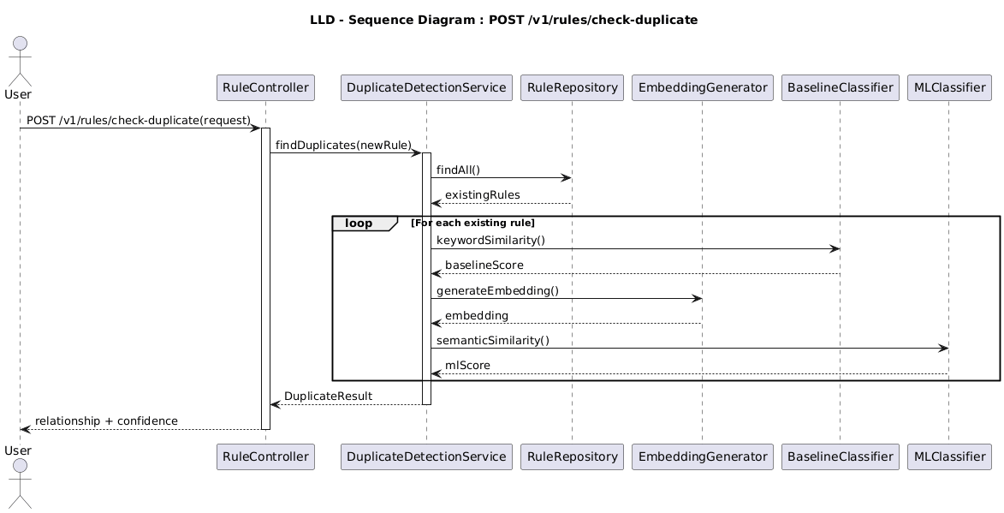

8.7 Conflict Detection
The Conflict Detection module identifies whether a newly extracted rule contradicts, modifies, extends, or is compatible with existing active business rules within the same workspace. Unlike duplicate detection, which identifies repeated business logic, conflict detection evaluates whether the proposed rule changes the intended business behavior or introduces inconsistencies into the rule repository.
Conflict detection operates only after successful rule extraction and schema validation.

8.7.1 Baseline Implementation
The baseline implementation uses deterministic rule comparison based on predefined business logic.
Each extracted rule is compared against existing active rules using exact field matching and predefined comparison rules.
The baseline evaluates the following attributes:
- Business Term
- Operation
- Conditions
- Threshold Values
- Scope
- Time Window
- Affected Fields
If contradictory operations or incompatible conditions are identified, the rule is marked for manual review.
This deterministic implementation serves as the baseline for evaluating the machine learning approach and acts as the fallback mechanism if the semantic comparison module is unavailable.

8.7.2 Machine Learning Implementation
The production implementation follows a two-stage conflict detection pipeline.

Stage 1 – Candidate Rule Retrieval
To avoid comparing every rule in the repository, the system first retrieves only the most relevant active rules.
Each extracted rule is converted into a semantic embedding using Sentence-BERT (SBERT). Cosine similarity is used to retrieve the Top-K most semantically related active rules within the same workspace.
This stage is used only to identify candidate rules and does not determine whether a conflict exists.

Stage 2 – Structured Rule Comparison
Each retrieved candidate is compared using the standardized rule representation.
The comparison engine evaluates:
Rule Component | Comparison Logic
Business Term | Same or Different
Operation | Compatible or Contradictory
Conditions | Equivalent, Broader, Narrower, or Different
Scope | Same, Overlapping, or Independent
Time Window | Same or Overlapping
Threshold Values | Equal, Increased, Decreased, or Conflicting
Affected Fields | Same, Partial, or Different
Based on these comparisons, the engine classifies the relationship as:
Relationship | Description
Compatible | Rule can coexist with existing rule
Extension | Adds additional conditions without contradiction
Modification | Updates an existing rule while preserving intent
Conflict | Contradicts existing business logic
Final conflict decisions are based on structured rule comparison rather than semantic similarity scores.

Conflict Resolution Strategy
When a potential conflict is detected, the system does not automatically reject or overwrite any rule.
Instead, it:
- Stores the extracted suggestion.
- Records the conflicting rule identifiers.
- Generates a structured comparison report.
- Routes the suggestion to manual review.
- Waits for reviewer approval before any further action.
Business rules are never modified automatically.

Model Input
The conflict detection module receives:
- Structured Extracted Rule
- Active Rule Repository
- Workspace Identifier
Example Input
{
"business_term": "Revenue",
"operation": "INCLUDE",
"conditions": [
"Order Status = Cancelled"
],
"scope": "Global"
}

Model Output
{
"candidate_rule_id": "R205",
"relationship": "Conflict",
"conflicting_attributes": [
"Operation"
],
"reason": "Existing rule excludes cancelled orders while proposed rule includes them.",
"conflict_confidence": “Conflict”
}

8.7.3 Implementation Details
The conflict detection module is implemented using:
Component | Technology
Sentence Embeddings | Sentence-BERT (SBERT)
Vector Search | PostgreSQL pgvector
Rule Comparison Engine | Custom Python Module
API Framework | FastAPI
Data Store | PostgreSQL
The comparison engine evaluates rule attributes individually and produces an explainable comparison report, enabling reviewers to understand why a rule was classified as a conflict.

8.7.4 Evaluation
Conflict detection is evaluated using manually labelled conflicting rule pairs.
Evaluation metrics include:
- Precision
- Recall
- F1 Score
- False Conflict Rate
- Missed Conflict Rate
- Conflict Classification Accuracy
Performance is measured separately for different conflict categories, including operation conflicts, threshold conflicts, scope conflicts, and time window conflicts.

Key Design Principle
Semantic similarity is used only for retrieving candidate rules. Final conflict classification is based on structured comparison of business rule attributes, ensuring explainable and deterministic conflict decisions.
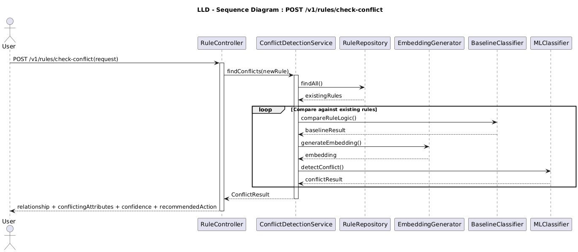

8.8 Completeness Check & Clarification Generation
The system never infers missing business information.
Before generating the final suggestion, every required rule component is verified.
Missing Information | System Action
Table | Request clarification
Column | Request clarification
Metric | Request clarification
Threshold | Request clarification
Date Range | Request clarification
Example:
Feedback:
Increase the threshold.
Generated clarification:
Which metric should be updated, and what should the new threshold value be?
Clarification requests and responses are stored separately while the original feedback remains immutable. A new Analysis Run is created after the clarification response is received.

8.9 Prediction Calibration and Decision Routing
Each processing module independently evaluates the reliability of its own prediction and produces a module-specific confidence score. Rather than combining these values into a single overall confidence score, the Rule Intelligence Engine preserves each confidence value independently, allowing reviewers to understand which stage introduced uncertainty into the processing pipeline.
This approach improves explainability and prevents a high-confidence prediction in one module from masking uncertainty in another.

8.9.1 Independent Module Confidence
Each module computes its own confidence score using techniques appropriate to its processing task.
Module | Confidence Produced
Classification | Classification Probability
Rule Extraction | Extraction Probability
Schema Validation | Validation Result (Pass/Fail) + Validation Confidence
Duplicate Detection | Candidate Similarity
Conflict Detection | Conflict Classification Result
These values are stored independently within the generated suggestion and remain available throughout the review process.

8.9.2 Classification Probability
The classification module returns the probability assigned to the predicted class by the classification model.
Example:
{
"feedback_type": "Business Rule",
"classification_confidence": 0.97
}
Low Classification Probability indicates uncertainty regarding the type of submitted feedback and results in manual review.

8.9.4 Schema Validation Confidence
Schema validation verifies extracted entities against the active Domain Pack.
Validation is performed for:
- Tables
- Columns
- Metrics
- Relationships
- Supported Operations
Example:
Entity | Validation
Revenue | Valid
Cancelled Orders | Valid
RevenueAmount | Missing
If mandatory schema elements cannot be validated, the suggestion is immediately routed for manual review regardless of other confidence values.

8.9.7 Decision Rules
The Rule Intelligence Engine does not rely on a single aggregated confidence score. Instead, routing decisions are based on predefined business rules and module-specific confidence values.
Condition | System Action
Schema Validation Failed | Manual Review
Mandatory Information Missing | Generate Clarification Request
Low Classification Probability | Manual Review
Low Extraction Probability | Manual Review
Duplicate Detected | Reviewer Verification
Conflict Detected | Senior Reviewer
Sensitive Business Rule | Senior Reviewer
Each condition is evaluated independently before a suggestion is assigned to a review queue.
Prediction probabilities are calibrated before use in downstream routing decisions. Calibration error is measured during evaluation and monitored as part of model validation. Routing decisions are based on calibrated probabilities together with schema validation, completeness checks, duplicate detection, conflict detection, and business rules rather than a single aggregated confidence score.

8.9.9 Implementation Details
The confidence produced by each module is generated using task-specific methods:
Module | Confidence Source
Classification | Softmax probability from DistilBERT classifier
Rule Extraction | Average token/entity confidence from the NER model
Schema Validation | Percentage of extracted entities successfully validated
Duplicate Detection | Structured comparison confidence following candidate retrieval
Conflict Detection | Confidence generated by the rule comparison engine
No weighted aggregation is performed across modules.

8.10 Review Routing
The final stage determines how generated suggestions enter the review process.
Routing decisions are based on:
- Classification result
- Schema validation status
- Duplicate detection result
- Conflict detection result
- Clarification requirement
- Business sensitivity
- Duplicate status.
- Conflict severity.
- Clarification requirement.
- Rule category.
- Business sensitivity.
The routing policy is summarized below.
Condition | Queue
Schema validation failed | Mandatory Manual Review
Missing mandatory fields | Clarification Required
Conflict detected | Senior Reviewer
Sensitive business rule | Senior Reviewer
Duplicate detected | Reviewer Verification
Normal validated suggestion | Standard Review

Once routing is complete, the suggestion is persisted in the Suggestion Repository and a suggestion_id with the current processing status is returned to the client. Human review continues asynchronously through the separate review workflow described in Section 7.

9. System Evaluation and Performance Measurement
The Rule Intelligence Engine (RIE) is evaluated using a manually reviewed benchmark dataset containing synthetic feedback generated across multiple business domains. Evaluation is performed independently for each processing module to identify strengths and weaknesses rather than relying on a single overall accuracy value.
The evaluation process compares the deterministic baseline with candidate machine learning models using identical frozen evaluation datasets. Candidate models are promoted only after demonstrating measurable improvements over the deterministic baseline according to the predefined acceptance criteria.

9.1 Evaluation Dataset
The evaluation dataset consists of manually reviewed business feedback that is not used during model training.
Dataset | Size | Purpose
Training | ~600 | Model Training
Validation | ~150 | Hyperparameter tuning and confidence calibration
Frozen Evaluation | ~200 | Final evaluation
Duplicate Pairs | ~150 | Duplicate detection evaluation
Conflict Pairs | ~150 | Conflict detection evaluation
Ambiguous Feedback | ~100 | Clarification evaluation
The frozen evaluation dataset is never used during model training, validation, or hyperparameter tuning to ensure unbiased performance measurement. All expected outputs are manually verified to establish a reliable ground truth for performance comparison.

9.2 Classification Evaluation
The classification module is evaluated independently using:
- Accuracy
- Precision
- Recall
- F1 Score
- Calibration Error
- Confusion Matrix
Performance is measured separately for each supported feedback category rather than reporting only an overall accuracy.
Example categories include:
- Metric Definition
- Filter Rule
- Mapping Rule
- Join Rule
- Access Rule
- Data Quality Issue
- General Product Feedback

9.3 Rule Extraction Evaluation
Rule extraction quality is evaluated independently for each component of the structured rule representation. Instead of measuring only whether an entire rule was extracted correctly, the system measures the accuracy of each individual field.
The following fields are evaluated separately:
- Business Term
- Operation
- Normalized Conditions (Field, Operator, Value)
- Scope
- Time Window
- Affected Tables and Columns
- Threshold Values
The following evaluation metrics are recorded:
- Field-level Precision
- Field-level Recall
- Field-level F1 Score
- Exact Rule Match Rate
- Schema Validation Pass Rate
Each extracted field is compared against the manually annotated ground truth to identify which parts of the extraction pipeline require improvement.

9.4 Duplicate Detection Evaluation
Duplicate detection performance is evaluated using labelled duplicate pairs.
Evaluation metrics include:
- Precision
- Recall
- F1 Score
- Recall@K
- False Positive Rate
- False Negative Rate
Performance is measured separately for:
- Exact duplicates
- Semantic duplicates

9.5 Conflict Detection Evaluation
Conflict detection is evaluated using manually labelled conflicting business rules.
Evaluation metrics include:
- Precision
- Recall
- F1 Score
- Conflict Detection Accuracy
- False Conflict Rate
- Missed Conflict Rate
- Conflict Recall
- Conflict Classification Accuracy
- Missed Conflict Rate
Performance is measured separately for different conflict categories, including:
- Logical contradictions
- Threshold conflicts
- Scope conflicts
- Time-window conflicts
- Permission conflicts
The False Conflict Rate measures the percentage of valid business rules that are incorrectly identified as conflicts. A lower False Conflict Rate reduces unnecessary manual review effort.

9.6 Clarification Evaluation
Since the system never infers missing business information, clarification generation is evaluated as an independent task.
The evaluation measures:
- Clarification Detection Precision
- Clarification Detection Recall
- Clarification Detection F1 Score
- Missed Clarification Cases
- Incorrect Clarification Requests
- Average Clarification Resolution Time
A clarification request is considered correct only when the submitted feedback genuinely lacks sufficient information for rule generation. False clarification requests are also tracked to minimize unnecessary reviewer intervention.

9.7 Baseline vs Machine Learning Comparison
Both the deterministic baseline and the machine learning pipeline are evaluated using identical datasets.
Metric | Deterministic Baseline | Candidate ML Model
Classification Accuracy | Measured | Measured
Per-category F1 Score | Measured | Measured
Complete Rule Accuracy | Measured | Measured
Duplicate Precision | Measured | Measured
Duplicate Recall | Measured | Measured
Recall@K | Measured | Measured
Conflict Precision | Measured | Measured
Conflict Recall | Measured | Measured
Calibration Error | Measured | Measured
Average Processing Time | Measured | Measured

Both approaches are evaluated using the same frozen evaluation dataset. Candidate machine learning models are promoted only if they demonstrate measurable improvements over the deterministic baseline while satisfying the predefined acceptance criteria. Thresholds for semantic candidate retrieval, structured duplicate detection, and structured conflict detection are finalized through empirical evaluation using the validation dataset.

9.8 Acceptance Criteria
The initial project will be considered successful if it satisfies the following measurable goals:
Component | Target
Classification Accuracy | ≥ 85%
Per-category F1 Score | ≥ 0.85
Complete Rule Accuracy | ≥ 80%
Duplicate Precision | ≥ 90%
Duplicate Recall | ≥ 90%
Recall@K | ≥ 95%
Conflict Precision | ≥ 85%
Conflict Recall | ≥ 85%
Missed Conflict Rate | ≤ 5%
Calibration Error | ≤ 0.05
Workspace Isolation Tests | 100% Pass
Idempotency Tests | 100% Pass
Background Job Retry Tests | 100% Pass
Baseline vs Candidate Model Promotion | Candidate model must outperform the deterministic baseline
Average API Response Time | < 2 seconds*
Docker Deployment | Successful
Manual Review Workflow | Functional

*The response time target is measured using CPU-based inference on an Intel Core i7-class processor with 16 GB RAM, using the distilbert-base-uncased checkpoint, a maximum feedback length of 256 tokens, single-request processing, and a concurrency level of 10 simultaneous requests.

10. Security and Operational Considerations
The Rule Intelligence Engine is designed with security, privacy, and governance as core architectural principles. Security controls are applied across API access, data storage, machine learning inference, human review, and audit logging to protect business information and ensure compliance with organizational policies.

10.1 Authentication and Authorization
All protected APIs require authentication using JSON Web Tokens (JWT).
Role-Based Access Control (RBAC) is enforced to ensure users can perform only authorized operations.
Role | Permissions
Business User | Submit feedback, view own suggestions, respond to clarification requests
Reviewer | Review suggestions, approve, reject or request clarification
Administrator | Activate business rules, manage datasets, models and system configuration
Every request is authenticated before entering the processing pipeline. Workspace membership and role-based permissions are verified before the requested operation is executed.

10.2 Workspace Isolation
All business data is isolated using authenticated workspace membership. The workspace identifier supplied in the request is validated against the authenticated user's authorized workspace memberships before any business operation is performed.
Each workspace maintains independent:
- Feedback
- Suggestions
- Business Rules
- Domain Packs
- Evaluation Runs
- Models
- Datasets
Cross-workspace access is prohibited and enforced through authenticated workspace authorization at the API layer together with workspace-filtered database queries.

10.3 Rate Limiting
To protect the system from abuse and denial-of-service attacks, API endpoints implement request rate limiting.
Example policy:
Endpoint | Limit
Feedback Analysis | 100 requests/hour/user
Batch Analysis | 10 requests/hour/user
Rule Activation | 20 requests/hour
Review APIs | 200 requests/hour
Requests exceeding configured limits return HTTP 429 (Too Many Requests).
Rate limits may be adjusted based on deployment requirements.

10.4 Sensitive Data Protection
Business feedback may contain confidential business logic or proprietary information.
The system protects sensitive information by:
- Using encrypted infrastructure storage volumes for database files and optional column-level encryption for sensitive business fields.
- Using HTTPS/TLS for all API communication.
- Restricting access through authenticated API endpoints.
- Applying workspace-level authorization checks.
Personally identifiable information (PII), if present, is masked before being displayed in logs or monitoring dashboards.

10.5 Logging and Audit Policy
System logs are intended for operational monitoring and debugging.
To reduce privacy risks:
- Raw feedback text is not stored in application logs.
- Only Feedback IDs, Suggestion IDs, timestamps and processing status are logged.
- Detailed feedback content remains accessible only through authorized database queries.
Every administrative action is recorded in the immutable Audit History repository.

10.6 External Model Data Policy
The Rule Intelligence Engine is designed to operate using locally deployed machine learning models.
Business feedback submitted to the system is not transmitted to external AI services unless explicitly configured by system administrators.
If external inference services are enabled in future deployments:
- User consent and organizational approval must be obtained.
- Data transmission must occur only over secure encrypted channels.
- External providers must comply with applicable data protection policies.

10.7 Data Retention and Deletion
The system maintains configurable data retention policies.
Typical retention guidelines include:
Data | Retention
Feedback | Configurable
Suggestions | Configurable
Audit History | Long-term retention
Evaluation Results | Version controlled
Background Jobs | Configurable
Expired records may be archived or permanently deleted according to organizational policies.
Deletion operations are recorded within the Audit History repository.

10.8 Prompt Injection and Malicious Input Handling
Submitted feedback is treated as untrusted input.
The Rule Intelligence Engine never executes instructions contained within business feedback.
Before processing:
- Input is validated against the API schema.
- Unsupported commands are ignored.
- System prompts and model instructions remain isolated from user-provided content.
- Feedback is interpreted only as business text for classification and rule extraction.
Suspicious or malformed requests are flagged for manual review and recorded for security analysis.

10.9 Failure Recovery and Fallback Strategy
If an ML component fails during processing:
• The failure is recorded in the Audit History.
• The background job is retried according to the configured retry policy when applicable.
• If recovery is unsuccessful, the deterministic baseline is executed where supported.
• The suggestion is routed to mandatory manual review.
• Production business rules remain unchanged.
• No business rule is automatically created or activated following model failure.

10.10 Operational Considerations
The Rule Intelligence Engine includes operational controls to improve reliability, maintainability, and recoverability.
Operational decisions include:
• Database Migration Tool: Alembic
• Background Job Framework: Celery with Redis
• Model Artifact Storage: Local Model Registry
• Vector Storage: PostgreSQL pgvector
• Job Retry Policy: Maximum of three retry attempts with exponential backoff
• Job Timeout: Configurable timeout for long-running background jobs
• Job Cancellation: Administrators may cancel queued or running background jobs
• Backup Strategy: Scheduled PostgreSQL backups with periodic restore verification
• Monitoring: Prometheus metrics with Grafana dashboards
• Error Tracking: Structured application logging with Sentry integration

10.11 Security Design Principles
The Rule Intelligence Engine follows the following security principles:
- Defense in depth through multiple validation layers.
- Least-privilege access using RBAC.
- Complete auditability of system actions.
- Separation of automated analysis, draft rule creation, and business rule activation.
- Secure handling of business data.
- Explainable AI outputs to support reviewer decisions.
- Fail-safe processing with deterministic fallbacks.
- No automatic deployment of AI-generated business rules.

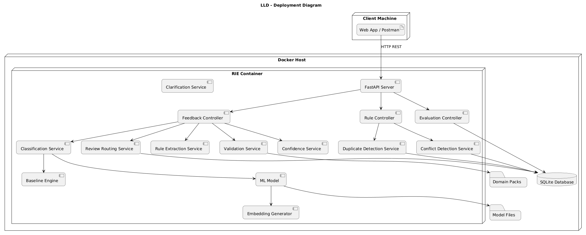

11. Implementation Roadmap
The Rule Intelligence Engine will be implemented over six weeks, with each phase focusing on a well-defined set of technical objectives and measurable deliverables. The roadmap follows an incremental implementation approach in which each phase produces independently testable deliverables before subsequent components are integrated into the complete Rule Intelligence Engine.

Phase 1 – Foundation & Dataset Preparation

Objectives
- FastAPI project setup
- PostgreSQL database setup
- Docker environment configuration
- Domain Pack design
- Synthetic dataset preparation
- Annotation guideline definition

Deliverables
- Running FastAPI project
- PostgreSQL schema
- Dockerized development environment
- Initial synthetic datasets
- Domain Pack configuration
- Annotation documentation

Phase 2 – Core Intelligence Engine

Objectives
- Feedback preprocessing
- Classification module
- Rule extraction module
- Schema validation
- Canonical structured rule generation

Deliverables
- Classification APIs
- Rule extraction APIs
- Canonical Structured Rule implementation
- Schema validation module
- Initial end-to-end processing pipeline

Phase 3 – Rule Intelligence & Review Workflow

Objectives
- Duplicate detection
- Conflict detection
- Clarification generation
- Prediction calibration and validation assessment
- Review routing
- Suggestion lifecycle implementation

Deliverables
- Structured duplicate detection engine
- Structured conflict detection engine
- Clarification workflow
- Review routing module
- Suggestion repository
- Human review workflow

Phase 4 – Background Services & Data Management

Objectives
- Celery worker services
- Redis configuration
- Job Status APIs
- Dataset Version repository
- Model Version repository
- Analysis Run repository
- pgvector index update service

Deliverables
- Background Job Manager
- Job Status APIs
- Dataset Version repository
- Model Version repository
- Evaluation management APIs
- Pgvector index management update service

Phase 5 – Evaluation, Security & Testing

Objectives
- Deterministic baseline vs candidate model comparison
- Performance evaluation
- Security implementation
- API testing
- Docker integration testing

Deliverables
- Evaluation report
- Evaluation metrics and acceptance criteria report
- Security implementation
- Automated API tests
- Docker deployment validation

Phase 6 – Documentation & Final Demonstration

Objectives
- System documentation
- User documentation
- Final testing
- Deployment validation
- Final project demonstration

Deliverables
- Final System Design Document
- REST API documentation
- Docker deployment package
- User guide
- Final project presentation
- End-to-end demonstration

11.1 Week-wise Execution Plan
Week | Activities | Deliverables | Success Criteria
Week 1 | FastAPI setup, PostgreSQL, Docker, Domain Packs, dataset preparation | Running project, database schema, synthetic datasets | Docker environment operational, ≥1000 labelled feedback samples prepared
Week 2 | Preprocessing, Classification, Rule Extraction, Schema Validation | Working analysis APIs, structured rule generation | Classification, canonical rule extraction, and schema validation successfully integrated
Week 3 | Duplicate detection, Conflict detection, Clarification generation, Review routing | Complete suggestion pipeline | Structured duplicate detection and structured conflict detection operational, clarification workflow functional
Week 4 | Background jobs, Dataset versioning, Model versioning, Evaluation APIs, Pgvector index management | Celery workers, Redis configuration, Job management APIs, version repositories | Asynchronous jobs operational, job status tracking functional
Week 5 | Model evaluation, Deterministic baseline vs candidate model comparison, Security implementation, API testing | Evaluation report, security validation, automated tests | Evaluation metrics satisfy predefined acceptance criteria, security requirements implemented, API tests passing
Week 6 | Documentation, Docker deployment, Final testing, Project demonstration | Final documentation, Docker image, presentation | End-to-end workflow demonstrated, operational deployment validated, and acceptance criteria satisfied

11.2 Final Deliverables
The completed Rule Intelligence Engine project will include:
- FastAPI application
- PostgreSQL database
- Docker deployment package
- Synthetic training and frozen evaluation datasets
- Three business domain packs
- Celery background job processing with Redis
- pgvector semantic search index
- Rule Intelligence REST APIs
- Human review workflow
- Analysis Run management
- Model and dataset version management
- Evaluation report with deterministic baseline vs candidate model comparison
- System Design Document
- REST API documentation
- Docker deployment guide
- Final project demonstration

11.3 Project Completion Criteria
The project is considered complete only when:
• All acceptance criteria defined in Chapter 9 are satisfied.
• End-to-end workflow executes successfully.
• Docker deployment is operational.
• Workspace isolation tests pass.
• Background job retry and failure handling are validated.
• Manual review workflow is functional.
• Candidate machine learning models satisfy the predefined promotion criteria before deployment.

